To: Those bidding this project.

We are looking for a 200MB-1G connection from Steamboat Springs School District Office or South Routt High School to Yampa Elementary.

South Routt School District is already on a 1G Centurylink MOE connection, serviced by Mammoth Networks, from Steamboat Springs School District Office to South Routt High School. This is why Yampa Elementary school could be serviced from either Steamboat Schools or Oak Creek, High School. The priority would be from Oak Creek High School but we could make either work. In summary the address locations are …
FROM:
- South Routt High School
  - 305 S Grant St., Oak Creek, CO 80467
OR
- Steamboat Springs School District
  - 325 7th St., Steamboat Springs, CO 80487
TO:
- Yampa Elementary School
  - 448 Main S., Yampa, CO 80483

As per the attached drawing construction would be needed to extend the CL fibre to the property line. We are also asking for bids from our property line to the school building in a 4” conduit with three 1,½” innerducts inside stubbed up the wall into a box. We (school personnel) will run a conduit inside the building to the switch location to meet this box on the wall. The blue solid line is conduit on school property to the building and the dotted line is the conduit inside the building.
Price in increments of 200MB, 500MB, 1GB

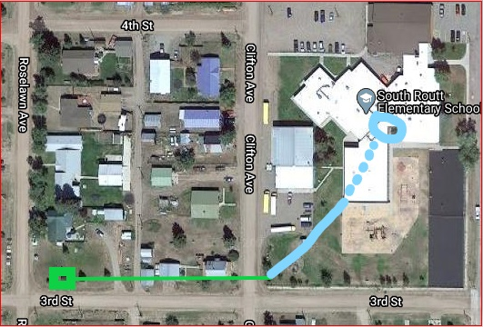

In summary … we are looking for a fibre or microwave connection of leased lit service from South Routt High School (or Steamboat Springs School District) with South Routt High School preferred to Yampa Valley elementary school. We would like it to be priced in increments of 200MB, 500MB, 1GB. In addition to our request for leased lit service we are also requesting leased dark fibre. Some construction will be required but as you see it is not great distances.

