CSP WHSINF2022
Computer Network Hardware and Wireless Access Points with Installation (E-Rate)

Issued by:
Waller ISD
c/o CRW Consulting
www.crwconsulting.com/ifcb

Online Submittal Deadline
December 14, 2021 | 11:59 pm Pacific Time

Table of Contents

Items below represent components which comprise this CSP package. Respondents are asked to review the package to be sure that all applicable parts are included. If any portion of the package is missing, please submit a question via the IFCB system at www.crwconsulting.com/ifcb.

Part Page
- Notice of Intention 3
- Response Requirements 4
- Instructions to Vendors 6
- Scope & Specifications 9
- Evaluation & Award of CSP 12
- General Terms and Conditions 14
- Pricing/Delivery Information 25
- Attachments 26

PART 1.0 – NOTICE OF INTENTION

The Purchasing Department of the Waller Independent School District (“WISD” or “District”) is conducting this procurement to establish a contract. The Initial Term of the prospective contract is a period of one (1) year, and the District is specifically requesting a one (1) year voluntary renewal in addition to the Initial Term. No contract shall be executed until it has been reviewed and approved by the Board of Trustees of the School District (“Board”) in a duly called and posted meeting of the Board. The District may access any awarded contract on an “as needed” basis from a list of contracts that have been competitively bid and awarded with qualified vendors based on the selection criteria set forth herein. Vendors are requested to submit an online response offering their total line of available products and services that are commonly purchased by school districts and other public, not-for-profit agencies and organizations.

Product(s) considered for award shall equal or exceed the technical, environmental, and performance standards and specifications as defined within this CSP and further described in the scope and specification section.

The good(s) and/or service(s) to be purchased under the awarded contract, if any, may be of indefinite delivery and indefinite quantity (IDIQ).

PART 2.0 – RESPONSE REQUIREMENTS

Please read carefully this entire CSP document and specifications. Complete all forms and submit your bid with all appropriate attachments in the manner required.
  - Request for Competitive Sealed Proposals (CSP) Documents
Documents relating to this purchasing solicitation are made available via the CRW Invitation for Competitive Bids (IFCB) system, available at: www.crwconsulting.com/ifcb. However, it is the responsibility of the vendor submitting a response to make certain that the IFCB system has the appropriate company name, authorized representatives, and contact information on file for the purpose of receiving notices, changes, addenda, and other critical information.
  - Tentative Time Table
WISD anticipates following the time table for this purchasing solicitation (all times listed are CST):
Item | Activity | Date & Time
1 | Solicitation starts to advertise (1st run) | November 3, 2021
2 | Solicitation advertised (2nd run) | November 10, 2021
3 | Deadline for submission of questions | November 12, 2021 at  11:59 PM Pacific Time
4 | Deadline for submission of responses and opening (See Part 3.0 Instructions to Vendors – for detailed requirements) | December 14, 2021 at  11:59 PM Pacific Time
5 | Bid Opening | December 15, 2021 at  2:00 PM Central Time
6 | Anticipated Board Meeting Approval | January 2022
7 | Anticipated Contract Period | April 1, 2022 – September 30, 2023
The table above is only an estimate and may vary.
  - Procurement Method
WISD maintains and uses documented procurement procedures, consistent with applicable Federal, State, local and tribal laws, regulations, rules, and standards for the acquisition of property or services. WISD is utilizing the Request for Competitive Sealed Proposals (CSP) method of procurement in accordance with Texas Education Code Section 44.031 Purchasing Contracts, Request for Competitive Proposals for services other than construction services.
  - Requirements for Return of CSP Responses
Respondents must submit all questions and proposals in the IFCB system by the established deadlines (day and time). WISD will not accept questions or proposals after the specified deadlines. Please refer to the “Instructions to Vendors” section to ensure that you submit all required information in the IFCB system. If a Respondent experiences a material system error or the IFCB system is down before the applicable submission deadline, questions and/or bids may be emailed to info@crwconsulting.com or faxed to 918-445-0049; however, questions or proposals submitted via email will be disqualified if the IFCB system is active at the time of the email or fax submission.
  - Pre-Bid/Proposal Conference – Not Applicable
  - Rights Reserved by WISD and Restrictions on CSP Process
  - WISD reserves the right to cancel this purchasing solicitation in whole or in part by issuance of a revised or amended Request for Competitive Sealed Proposals.
  - WISD further reserves the right to award one or more contracts to a single or to multiple prospective vendors or to make no award. The decision to award multiple contracts, award only one contract, or to make no awards rests solely with WISD. WISD may make multiple awards, and this fact should be taken into consideration by each vendor.
  - WISD assumes no financial responsibility for any costs incurred by prospective vendors in developing and submitting a response or any amendments or addenda, participating in bid conferences, participating in any negotiation sessions or discussions, or any other costs incurred by vendors prior to award of a contract pursuant to this CSP.
  - WISD reserves the right to reject any and/or all responses and to award contracts for products or services as may appear advantageous. WISD further reserves the right to accept, reject, or negotiate modifications in any terms of a proposed vendor’s response or any parts thereof. WISD further reserves the right to waive any formalities or technicalities if deemed in the best interest of the District. WISD shall be the sole judge of quality and equality.
  - Questions and Clarification
    - Questions regarding the requirements specified in this purchasing solicitation must be submitted within the IFCB system on or before November 12, 2021 at 11:59 pm PST. Questions received after the specified date/time will not be considered.
    - WISD will not answer verbal or emailed questions, as all questions are required to be submitted via the IFCB system; any responses to a prospective vendor’s questions will be posted within the IFCB system.

PART 3.0 – INSTRUCTIONS TO VENDORS

This portion of the CSP includes instructions on the format vendors must follow in preparing and submitting their online responses.
  - Compliance with Specifications
Vendors are required to respond to all requests identified in this CSP and indicate their acceptance or objection to the terms of the CSP and the terms of the Agreement. Any exceptions to the terms and conditions in the CSP or the Agreement must be clearly indicated in the appropriate section of the vendor’s submitted response. Each vendor, by making its response, represents that the vendor has read, understands, and, except to the extent of any objections in vendor’s response, agrees to the terms of the CSP and the Agreement.
  - Required Response Format
Vendors shall submit responses online in the IFCB system at the following address: www.crwconsulting.com/ifcb. Responses should be direct, concise, complete, and unambiguous. Please ensure that you respond to all documents and attachments in this Request for Competitive Sealed Proposals.
  - General Corporate and Contact Information
Vendor agrees to provide WISD with the following financial information if requested by WISD at any point during the procurement process, including before or after contract award: If public, the vendor’s income statement, balance sheet, and cash flow for the past three (3) years; if private, the vendor’s audited financial statements for the past two years (if available). A vendor’s failure to provide this financial information may impact the WISD Administration’s recommendation to the WISD Board of Trustees for the award of a contract.
  - Response Submission Location and Opening
Proposals shall be received in the IFCB system no later than 11:59 PM Pacific Time on December 14, 2021, as specified in this purchasing solicitation. Proposals will be publicly opened on December 15, 2021 at 2:00 PM Central Time at the Waller ISD Business Office located at 1914 Key Street, Waller, TX 77484, and the District will read aloud the names of the Respondents and, if any are required to be stated, all prices stated in each proposal. No provisions or exceptions are made for late submission due to actions or consequences of the Vendor or a third-party. Any responses received after the submittal deadline date and time will be disqualified.
  - Submission of Responses
WISD will only accept bids and proposals submitted online. Deviations from any terms, conditions, and/or specifications of the CSP or the Agreement shall be conspicuously noted in writing by the Vendor in the proposal. Copyrighted proposals are unacceptable and may be disqualified.
  - Addendum
Any interpretations, corrections, additions, or changes to this CSP will be communicated to vendors by the issuance of an addendum. It is the responsibility of the vendor, prior to submitting their response, to determine whether an addendum was issued. All vendors shall comply with the requirements specified in any addendum issued by WISD.
  - Disqualification
Partial or incomplete bids or proposals that otherwise fail to meet the response requirements set forth in the purchasing solicitation will be disqualified. A vendor may also be disqualified before or after the responses are unsealed, upon evidence of collusion with the intent to defraud, or evidence of intent to perform other illegal activities for the purpose of obtaining an unfair competitive advantage.
  - Environmental Initiatives
WISD is committed to reducing waste and promoting energy conservation. Toward that end, vendors responding to this solicitation are encouraged to provide their company’s environmental policy and green initiative.
  - Interpretation
This purchasing solicitation represents the basis for any award and supersedes all prior offers, negotiations, exceptions and understandings (whether orally or in writing). Submitted responses should be self-explanatory and should not require any clarification or additional information.
  - No Return of Responses; Withdrawal of Responses
Once submitted, WISD will not return responses to vendors. A response that has been submitted to WISD may be withdrawn in the IFCB system prior to the deadline for submission of responses; however, proposals may not be withdrawn for a period of ninety (90) business days following the opening. No proposals may be withdrawn without the District’s written approval after a contract has been signed or performance has begun.
  - Non-Collusion Statement
Vendors are required to certify a Non-Collusive Statement. Vendors are required to state the party submitting a response, that such response is genuine and not collusive or sham; that vendor has not colluded, conspired, connived or agreed, directly or indirectly, with an entity or person, to put in a sham response or to refrain from bidding, and has not in any manner, directly or indirectly, sought by agreement or collusion, or communication or conference, with any person, to fix the response price or of any other vendor, or to fix any overhead, profit or cost element of said response price, or of that of any other vendor, or to secure any advantage against WISD or any person interested in the proposed contract, and that all statements in said response are true.
  - Open Records Policy
WISD is a governmental body subject to the Texas Public Information Act. Responses submitted to WISD as a result of this purchasing solicitation may be subject to release as public information after any contracts are executed or the procurement is terminated. If a vendor believes that its response, or parts of its response, may be excepted from disclosure under Texas law, the vendor must specify page-by-page and line-by-line the parts of the response which it believes are excepted. In addition, the vendor must specify which exception(s) to the Texas Public Information Act are applicable and provide detailed reasons to substantiate the exception(s). Vague or general claims to confidentiality will not be accepted. WISD assumes no obligation or liability relating to the disclosure or nondisclosure of information submitted by vendors.
  - Preferences
To the extent permitted by applicable law, WISD may apply applicable preferences for Texas resident vendors in the event of a tie bid. Preferences must be explicitly claimed by vendor and may not be applicable in procurements and/or contracts involving federal funds.
  - Responsible Vendor
A responsible vendor is a vendor who has adequate financial resources (or the ability to obtain such resources), can comply with the delivery requirements, and is a qualified and established firm regularly engaged in the type of business that provides the items listed herein.
  - Responsive Submittals
Submissions shall be deemed responsive if they comply with all material and administrative aspects of this purchasing solicitation.
  - Similar Products
Whenever an article or material is defined by WISD in this purchasing solicitation by describing a proprietary product or by using a manufacturer, catalog, brand, or model name, such use is descriptive only, and the terms “or equivalent” and “or equal” if not inserted shall be implied (as applicable). The specified article or material shall be understood as indicating type, function, minimum standard of design, efficiency, and quality desired, and shall not be construed as to exclude other manufactured products or comparable quality, design, and efficiency (as applicable). Respondents should indicate that products and services are “as specified” or “equal” in the proposal. If proposing other than referenced specifications, the proposal must include the manufacturer, catalog, brand, or model name offered, and complete descriptive information of said article must be included with the proposal. If a Respondent takes no exception to the specifications or reference data set forth in this purchasing solicitation, the District will assume that goods and services will be furnished as specified herein.
  - WISD is Tax-Exempt
WISD is tax-exempt. Response prices should not include taxes.
  - Conflict of Interest (CIQ Form – must be filled out and attached to response)
WISD is required to comply with Texas Local Government Code Chapter 176, Disclosure of Certain Relationships with Local Government Officers. House Bill 23 significantly changed Chapter 176 as well as the required disclosures and the corresponding forms. As of September 1, 2015, any vendor who does business with WISD or who seeks to do business with WISD must fill out the new Conflict of Interest Questionnaire (CIQ) whether or not a conflict of interest exists.
3.20 Interlocal Cooperation Act
WISD may allow other governmental entities, including other school districts, to “piggyback” onto any existing contract between WISD and Vendor entered into pursuant to this CSP. Vendor expressly agrees that WISD may disclose Vendor’s response, including, but not limited to, pricing information, to other governmental entities. Accordingly, as permitted under the Interlocal Cooperation Act, Chapter 791 of the Texas Government Code, and Chapter 271, Subchapter F of the Texas Local Government Code, other governmental entities that have entered into an Interlocal Agreement with WISD are authorized to enter into separate and independent contracts with Vendor that employ the same negotiated terms and conditions contained in an existing contract(s) between WISD and Vendor. Any such separate, independent contract developed as a result of this purchasing solicitation and/or the Agreement is exclusively between such other governmental entity and Vendor and shall have no effect or impact on WISD or WISD’s contract with Vendor. It is expressly understood that WISD shall in no way be liable for the obligations of any other governmental entity contracting with Vendor pursuant to this section.

PART 4.0 – SCOPE & SPECIFICATIONS

  - Request for Competitive Sealed Proposals Defined
The intention of this Request for Competitive Sealed Proposals (CSP) is to solicit responses for Computer Network Hardware and Wireless Access Points with Installation. WISD is utilizing the Request for Competitive Sealed Proposals (CSP) method for the procurement of this service in accordance with Texas Education Code Section 44.031 Purchasing of Contracts, Item (2) Request for Competitive Sealed Proposals. For general information regarding the CSP process, please submit a question in the IFCB system at www.crwconsulting.com/ifcb.

The purchase of equipment and installation services will begin no earlier than April 1, 2022, with the requirement that equipment is installed and operational by July 31, 2022, with the option to voluntarily renew for an additional one (1) year term. WISD intends to seek E-Rate funding/reimbursement for the goods/services provided by Vendor, and the Terms and Conditions for E-Rate Procurements and Purchases in Part 8.0 Attachments of this CSP shall apply to this purchasing solicitation and any resulting transaction(s).
  - Scope of Services
WISD is requesting proposals for network equipment and installation to service its new high school campus located at 31213 Waller Spring Creek Rd, Waller, TX 77484. All equipment, unless otherwise specified, is to be installed and configured. Equipment includes switches, wireless access points, fiber-optic modules, and uninterruptable Power Supplies (UPS). Installation will be performed in approximately twenty (20) locations (MDF, IDFs) within the new high school, as further detailed in the “Pricing Detail” exhibit in Part 8.0 Attachments. Equipment and capacity requirements are the best estimates currently available. The District reserves the right to modify quantity and configuration requirements. The vendor agrees to sell the District the revised quantity of items at the unit price (or lower) as stated in the CSP regardless of quantity changes. It is required that the work be scheduled around student class time to avoid any possible disruption or interference.
  - Specifications
It is the intention of WISD to establish one or more contract(s) with highly qualified Vendor(s) for network equipment and wireless access points, with installation and configuration of same. Vendor(s) shall, at the request of WISD, provide these products and/or services under the terms of this CSP and the Agreement set forth in Part 6.0 General Terms and Conditions. All items offered must be new, in first class condition, including containers suitable for shipment and storage, unless otherwise indicated on the proposal. Each section (4.3.1 and 4.3.2) below will be a turnkey solution. Vendor is responsible for installation and configuration, of network equipment (in the case of section 4.3.1) and wireless access points (in the case of section 4.3.2) unless otherwise specified. For network equipment, 3-year 8x5xNBD support must be included in pricing. Vendors submitting proposals on this project must be able to demonstrate the ability to install and configure a project of this scope. References provided should be for projects of similar size and scope. Each section (4.3.1 and 4.3.2) may be awarded to a single vendor. A vendor may be awarded multiple sections. Installation & configuration includes transportation of equipment to the installation site, unboxing, assembling, mounting, powering up, attaching cables as required, configuring equipment to meet district needs, disposing of trash in on-site receptacle, and providing hardware manuals and documentation to district staff.

4.3.1 Network Equipment
Network equipment will be deployed and installed in approximately 20 telecommunications facilities in Waller High School. The anticipated rooms for installations and the equipment listing for each room can be found in the document titled “MDF-IDF Detail” in Part 8.0 Attachments of this CSP packet.
- 24-port 1/10/25 Gbps Layer 3 switch with at least two 40/100 Gbps uplinks and 650w power supply (Cisco C9500-24YAC with C9K-PWR-650WAC-R or equivalent) quantity 1
- 48-port POE 1 Gbps POE switch with 25 Gbps uplink and ≈ 1620 watts of POE power (Cisco C9300-48H with Cisco C9300-NM-2Y network module and 1900w power supply PWR-C1-1900WAC-UP or equivalent) quantity 20
- 48-port POE 1 Gbps POE switch with ≈ 1620 watts of POE power (Cisco C9300-48H and 1900w power supply PWR-C1-1900WAC-UP or equivalent) quantity 41
- 40 Gbps Fiber Module (Cisco QSFP-40G-LR4-FL or equivalent) quantity 2
- 25 Gbps capable SFP28 Fiber Module (Cisco SFP-10/25G-LR-S or equivalent) quantity 40
- 1-Meter Stacking Cable for 48-port switches (Cisco Stack-T1-1M or equivalent) quantity 61
- 2200VA Rack Mount UPS (APC SU2200R3X167 or equivalent) quantity 27

4.3.2 Wireless Access Points
Wireless Access Points and the Wireless Access Point Controller will be deployed and installed throughout Waller High School at locations designated by Waller ISD staff.
- Wireless Access Point Controller with NBD support (Aruba JY792A - Aruba MCR-HW-5K Mobility Conductor HW Appliance for up to 5K devices, with Aruba H8FZ7E 5yr NBD support and (2) Aruba JW124A power cords or equivalent) quantity 1
- 802.11ax Omnidirectional Wireless Access Point (Aruba R7J28A – Aruba AP-635 (US) Campus AP or equivalent) quantity 423
- Suspended Ceiling mounting bracket (Aruba R3J16A – AP-MNT-B AP mount bracket for suspended ceiling or equivalent) quantity 423
- 802.11ax Outdoor Omnidirectional Wireless Access Point (Aruba R4H18A - Aruba AP-575 (US) Outdoor 802.11ax WAP or equivalent) quantity 15
- Outdoor Pole/Short Wall mounting kit (Aruba JW053A - Aruba AP-270-MNT-V2 AP-270 Series Outdoor Pole/Wall Short Mount Kit or equivalent) quantity 15
- 10G SFP+ LC LR 10km SMF Transceiver (Aruba J9151E or equivalent) quantity 2
- Licensing for Wireless Access Points (Aruba JW619AAE - Aruba LIC-K12-1 with 1-year support or equivalent) quantity 438
- 5-yr Foundation Care software extension for above (Aruba H8HU6E - Aruba 5Y FC SW E/R lic K12 AOS Bdle SVC [for JW619AAE] or equivalent) quantity 438

4.4 Estimated Annual Expenditures
PLEASE NOTE THERE IS NO GUARANTEED ANNUAL VOLUME. The District makes no guarantees as to quantities and may purchase more or less than those stated in this purchasing solicitation, from zero up to 100% of items approved, throughout the contract period listed in this purchasing solicitation, subject to verification of the same or lower prices and conditions of this purchasing solicitation. All purchases will be made contingent on the availability of funds.

4.5 Performance of Work on WISD Property
Any contract awarded under this CSP will include provisions requiring that all servicemen and technicians for Vendor be in company uniform while on WISD property. Servicemen/technicians will be required to check-in at the front office to gain access to work site during school hours. Upon completion of work, servicemen/technicians will be required to check-out through the front office and have their service ticket signed by a campus representative. The use of tobacco is prohibited on District property.

PART 5.0 – EVALUATION AND AWARD OF RESPONSES

In accordance with applicable laws, rules, and regulations for public purchasing, award(s) will be made to the responsible vendor(s) whose response(s) is/are determined, after evaluation by the WISD evaluation committee, to be the best value to WISD. To qualify for evaluation, a response must have been submitted on time and must materially satisfy all mandatory requirements identified in this purchasing solicitation.
  - Evaluation Criteria
A committee selected by WISD will review and evaluate all responses and make a recommendation to the WISD Board of Trustees. By including each of the criteria in Texas Education Code § 44.031(b), below, WISD has fulfilled Section 44.031(b)’s requirement that it “shall consider” the criteria listed in 44.031(b); in accordance with Module 5 of the TEA FASRG, WISD has determined which criteria should be considered most important and has assigned weights/points to each criterion based on how important it is. WISD will base a recommendation for contract award on the following factors, in accordance with Texas Education Code § 44.031:
Evaluation Factors | Weighted Value
1. Price of eligible goods and services |  | 40 Points __
2. Reputation of Vendor and of Vendor’s goods and/or services  (Preferred minimum 5 years’ experience in business in Houston or surrounding areas)  (In the last 5 years, preferred completion of 3 projects of comparable size & scope) |  | 20 Points __
3. Quality and value of Vendor’s goods and/or services |  | 30 Points __
4. Extent to which the goods and/or services meet WISD’s needs (including probability of continuous availability, vendor’s service and delivery capabilities, warranty and warranty service history, and insurance coverages) |  | 30 Points __
5. Vendor’s past relationship with WISD |  | 30 Points __
6. Impact on the ability of WISD to comply with laws and rules relating to HUBs |  | 10 Points __
7. Total long-term cost to WISD to acquire Vendor’s goods and/or services |  | 20 Points __
 | Total | Points 180
  - Awards
The District reserves the right to participate in a process with each vendor to clarify the project. The District may at its discretion, and at no cost to the district, invite any Vendor to appear for questioning during response evaluation for the purpose of clarifying statements in the response. In addition, the District reserves the right to award without further discussion. Therefore, responses should be submitted initially with the most favorable terms that the vendor can propose. Awards will be based on the criteria set forth within this purchasing solicitation and may be made to the successful vendor(s) for the total line of products and services submitted. WISD reserves the right to award contracts to multiple vendors. WISD shall comply with the Texas Public Information Act in the event WISD receives an open records request for information relating to responses submitted in response to this CSP.
  - Estimated Quantities
WISD makes no guarantee or commitment of any kind regarding usage of any contracts resulting from this solicitation or quantities that will actually be purchased.
  - Inspection & Acceptance
Awarded vendor(s) shall deliver any goods or services awarded under this purchasing solicitation to the WISD Department issuing a Purchase Order. If delivery is not or cannot be made within proper time period, the awarded vendor must receive authorization from the issuing WISD Department for the delayed delivery. If defective or incorrect goods are delivered, WISD may make the determination, in its sole discretion, to return the goods to the vendor at no cost to WISD. The vendor agrees to pay all shipping and handling costs for any such return shipment. The vendor also shall be responsible for arranging the return of the defective or incorrect goods.
  - Minority & Women’s Business Enterprise (MWBE), Historically Underutilized Business (HUB), and Small Business Enterprise (SBE) participation
WISD encourages the use of HUB, MWBE, and SBE both as prime and subcontractors. However, these entities must meet the same minimum standards and requirements as the prime contractor. It will be the responsibility of the prime contractor to pre-qualify any subcontractors offered as HUB, MWBE and SBE participants. Vendors shall indicate on their submitted responses whether or not they are a HUB, MWBE, or SBE vendor and with whom they are certified, e.g., State, City, Federal.
  - Formation of Contract
A response to this purchasing solicitation is an offer to contract with WISD based upon the terms, conditions, scope of work, and specifications contained in this purchasing solicitation. A solicitation/response does not become a contract unless and until it is accepted by WISD after approval by the WISD Board of Trustees. Award of this CSP by the Board of Trustees is not a guarantee of purchase. Decisions to purchase awarded items shall be dependent upon funding and the needs of the District. All District purchases will be in the form of a Purchase Order issued by Waller ISD to the vendor. Waller ISD reserves the right to require a separate, written contract that is properly executed by both parties for any purchase under this CSP; however, by submitting a proposal, the Vendor agrees that, in the absence of such separate contract, this purchasing solicitation (including all terms and conditions contained herein), the portion of Vendor’s bid/proposal submitted in response to this purchasing solicitation that is satisfactory to the District, and a Purchase Order duly issued by the District following the approval of the Board of Trustees shall constitute a legally binding agreement between the parties.
  - Non-Exclusive Contract
Any contract resulting from this purchasing solicitation is non-exclusive and shall be awarded with the understanding and agreement that it is for the sole convenience of WISD. WISD is free to have multiple contracts for any awarded goods and services and may initiate other purchasing solicitations or purchasing activity with other vendors at any time, in WISD’s sole discretion.
  - Pricing
Vendors must identify all costs, fees, and charges for which WISD may be billed within their response to this solicitation. Costs, fees, or charges not indicated in Vendor’s response will not be paid. WISD requires that the pricing submitted in responses be offered as a quantity one price. WISD may request awarded vendor(s) to provide discounts or other adjustments to the quantity one price for larger orders, on a per-purchase order basis. If discounts or quantity prices are offered by an awarded vendor, the vendor must also offer the same reductions in pricing to be available for orders of similar size.

PART 6.0 – GENERAL TERMS AND CONDITIONS

These terms and conditions apply to all purchases in connection with the purchasing solicitation to which they are attached. The term “Vendor” means each awarded vendor chosen by WISD. These General Terms and Conditions are part of the final contract and any other agreement, purchase order, work order, invoice, order acknowledgement, bid/response/award forms, and/or other commercial documents issued in connection with this purchasing solicitation. VENDORS ARE RESPONSIBLE FOR IDENTIFYING ANY EXCEPTIONS TO THESE TERMS AND CONDITIONS - Any exceptions must be CLEARLY noted in the VENDOR RESPONSE. Responses that are qualified with conditional clauses, items not called for, or other irregularities may be considered non-responsive by WISD and eliminated from further consideration by WISD.

This Agreement is entered into by and between Waller Independent School District (“WISD”) and Vendor, having submitted a response to a purchasing solicitation issued by WISD and whose response has been accepted and awarded by WISD. In consideration of the mutual covenants and conditions contained in this Agreement and other good and valuable consideration, the receipt and sufficiency of which are hereby acknowledged, WISD and Vendor, intending to be legally bound, and subject to the terms, conditions, and provisions of this Agreement, agree as follows:
- Agreement Terms; Amendment
The terms of this Agreement, including the terms of the CSP and all attachments, shall govern all procurements conducted hereunder. No pre-published terms on the Vendor’s order acknowledgments, invoices, or other forms shall have any force or effect, and no supplement or other modification of this Agreement shall be permitted, unless and until a written amendment to this Agreement is properly executed by WISD’s Superintendent (or designee) after any necessary approvals have been obtained from the WISD Board of Trustees.
- Assignment of Agreement
Vendor may not assign this Agreement or any of its rights, duties, or obligations hereunder without the prior written approval of WISD. Any attempted assignment of this Agreement by Vendor shall be null and void. Any purchase or work order made as a result of this Agreement may not be transferred, assigned, subcontracted, mortgaged, pledged, or otherwise disposed of or encumbered in any way by Vendor without the prior written approval of WISD. Vendor is required to notify WISD when any material change in operations occurs, including but not limited to, changes in distribution rights for awarded products, bankruptcy, material changes in financial condition, change of ownership, and the like, within three (3) business days of such change.
- Buy America Act
WISD has a preference for the purchase, acquisition, or use of goods, products, or materials produced in the United States when spending certain federal funds. Purchases that are made with non-federal funds or grants are excluded from the Buy America Act.
- Captions
The captions herein are for convenience and identification purposes only, are not an integral part hereof, and are not to be considered in the interpretation of any part hereof.
- Catalog Discounts
In the event of a catalog discount type solicitation, Vendor may be allowed to make additions and/or deletions from Vendor’s offerings on an annual basis during the Agreement renewal period, in WISD’s sole discretion, provided the item(s) substituted are of a like quality and category. These changes will be compliant with the format of Vendor’s original response (i.e. manufacturer name, product category, or entire catalog discount). WISD will send notification to Vendor(s) seeking any additions and/or deletions, and Vendor will return these proposed changes on company letterhead within the given timeframe. If WISD, in its sole discretion, accepts Vendor’s proposed changes, such changes will remain in effect for the entire year until the next renewal period.
- Compliance with Laws
Vendor shall comply with all applicable federal, state, and local laws, statutes, ordinances, standards, orders, rules, and regulations, including, as applicable, workers’ compensation laws, minimum and maximum salary and wage statutes and regulations, prompt payment and licensing laws and regulations, the Davis-Bacon Act (40 U.S.C. § 276a / 29 CFR Part 5), the Copeland “Anti-Kickback” Act (18 U.S.C. § 874 / 29 CFR Part 5), the Equal Opportunity Employment requirements (Executive Orders 11246 and 11375 / 41 CFR Chapter 60), the McNamara-O’Hara Service Contract Act (41 U.S.C. 351), Section 306 of the Clean Air Act (42 U.S.C. § 1857h, Section 508 of the Clean Water Act (33 U.S.C. § 1368), Executive Order 11738, Environmental Protection Agency regulations (40 CFR Part 15), the Contract Work Hours and Safety Act (40 U.S.C. § 3701-3708; 29 C.F.R. Part 5), the Uniform Administrative Requirements, Cost Principles, and Audit Requirements for Federal Awards (2 CFR Part 200), the Education Department General Administrative Regulations, 2 C.F.R. Parts 200 and 3474, and 34 C.F.R. Parts 75-77 and 81 (“EDGAR”), mandatory standards and policies contained in the state energy conservation plan issued in compliance with the Energy Policy and Conservation Act (Pub. L. 94-163, 89 Stat. 871), E-Rate program rules and regulations, and all applicable requirements and regulations, including those related to reporting, patent rights, copyrights, data rights and those mandated by federal agencies making awards of federal funds to WISD. Vendor understands that Vendor is ineligible to receive a contract award with WISD if Vendor or its principal(s) is listed on the government wide exclusions in the System for Award Management (Debarment and Suspension Orders Executive Orders 12549 and 12689). For the entire duration of this Agreement, Vendor and all subcontractors shall maintain all required licenses, certifications, permits, and any other documentation necessary to perform this Agreement. Vendor must comply with all state and local building code requirements unless otherwise specifically provided in the WISD’s Purchase Order, and Vendor must pay all fees and charges for connections to outside services and for use of property outside the project site. When required or requested by WISD, Vendor shall furnish WISD with satisfactory proof of Vendor’s compliance with this provision.
- Confidentiality
Vendor and WISD agree to secure the confidentiality of all information and records in accordance with applicable federal and state laws, rules, and regulations. Vendor and WISD understand that the Family Educational Rights and Privacy Act (FERPA), 20 U.S.C. § 1232g, governs the privacy and security of educational records and information and agree to abide by FERPA rules and regulations, as applicable. Vendor also acknowledges that WISD is subject to the Texas Public Information Act, and Vendor waives any claim against and releases from liability WISD, its officers, employees, agents, and attorneys with respect to disclosure of information provided under or in this Agreement or otherwise created, assembled, maintained, or held by Vendor and determined by WISD, the Attorney General of Texas, or a court of law to be subject to disclosure under the Texas Public Information Act.
- Contract Term
The initial term of the Agreement is for a period of one (1) year with the option to voluntarily renew for one (1) additional year, subject to extension by the District as permitted under applicable law, including, but not limited to E-Rate program rules and regulations. The phrase “Term” in this Agreement shall mean the then-current Term of the Agreement, whether the initial term or a renewal term. At the District’s option, there may be an additional 90-day transitional period added to the end of the initial term or any renewal term. The Agreement prices, terms, and conditions are to remain in force during the transitional period unless mutually agreed upon by both parties. Should the Agreement with the Vendor terminate during the initial or any renewal term for any reason, the District reserves the right to have the same transitional period, prices, terms and conditions as if the Agreement terminated at the expiration of that term.
- Criminal History Review (Ch. 22 Contractor Certification: Contractor Employees Form – must be filled out and returned, if applicable)
Prior to commencing any work under the Agreement, if Vendor contracts with WISD to provide services, Vendor must comply with all requirements relating to criminal history information required by Tex. Educ. Code Chapter 22. Vendor must also ensure subcontractors’ compliance with Tex. Educ. Code Chapter 22 requirements. Covered employees with disqualifying criminal history are prohibited from serving at WISD; Vendor and any subcontracting entity may not permit a “covered employee” to provide services at a school if the employee has a “disqualifying criminal history” (as those terms are defined below). If Vendor receives information that a covered employee has a reported disqualifying criminal history, then Vendor will immediately remove the covered employee from the project/contract and notify WISD in writing within three (3) business days. If WISD, in its sole discretion, objects to the assignment of a covered employee for any reason, including, but not limited to, on the basis of the covered employee’s criminal history record information and/or insufficient qualifications, lack of experience, and the like, based on information gathered by WISD through the procurement and/or contracting processes, Vendor (and each subcontractor) agrees to discontinue using that covered employee to provide services on WISD’s project/contract. “Covered employees” means employees, agents or subcontractors of Vendor or a subcontractor who has or will have continuing duties related to the services to be performed on WISD’s project/contract and has or will have direct contact with WISD’s students. “Disqualifying criminal history” means: (1) For employees of a contracting or subcontracting entity that is providing engineering, architectural, or construction services on a project to design, construct, alter, or repair a public work: (1) a conviction or other criminal history information designated by WISD; (2) a felony or misdemeanor offense that would prevent a person from being employed under Texas Education Code § 22.08341(d), that is: conviction during the preceding 30 years (if at the time of the offense, the victim was under 18 or was enrolled in a public school) of: (a) a felony offense under Title 5, Texas Penal Code; (b) an offense on conviction of which a defendant is required to register as a sex offender under Chapter 62, Texas Code of Criminal Procedure; or (c) an offense under federal law or the laws of another state that is equivalent to (a) or (b); (2) For employees of all other contracting or subcontracting entities: (1) a conviction or other criminal history information designated by WISD; (2) a felony or misdemeanor offense that would prevent a person from being employed under Texas Education Code § 22.085(a), that is: (a) conviction of a felony offense under Title 5, Texas Penal Code if at the time of the offense, the victim was under 18; (b) conviction of or placement on deferred adjudication community supervision for an offense for which a defendant is required to register as a sex offender under Chapter 62, Texas Code of Criminal Procedure; or (c) conviction of an offense under federal law or the laws of another state that is equivalent to (a) or (b). WISD shall be solely responsible for making the final determination of what constitutes direct contact with WISD’s students and what constitutes a disqualifying criminal history. The criminal history record information review obligation applies if Vendor contracts with WISD to provide services; it does not apply to a contract for the purchase of goods or real estate.
- Customer Reference List
Vendor shall submit a customer reference list in Part 8.0 Attachments as part of its Response, and the District prefers that the Vendor include references from at least three (3) public schools, universities, or business establishments for which similar work has been performed in the past 5 years. It is preferred that references demonstrate a minimum of five years’ experience in business in the Houston or surrounding areas and, within the five-year period, a minimum of three projects of comparable size and scope. Vendors should also provide current names, complete mailing addresses and phone numbers for reference representatives along with a description of the type of work performed and approximate value for each referenced project. Vendor references will be considered in evaluating the Reputation of Vendor and of Vendor’s goods and/or services.
- Customer support
Vendor shall provide timely and accurate technical advice and sales support to WISD and WISD staff. Vendor shall respond to requests for customer support within a maximum of 48 hours after receipt of the request. Repeated failure to timely respond to requests for support shall be grounds for termination of this Agreement. Vendor shall provide training to WISD staff regarding products and/or services supplied by Vendor, at no additional charge, if requested by WISD. Any awarded vendor shall process District orders upon receipt without any increase in price to the District and shall pass along any price cuts to the District immediately and work continuously to enhance services, products, and pricing.
- Entire Agreement
This Agreement, the purchasing solicitation issued by WISD, the portion of Vendor’s response submitted in response to WISD’s purchasing solicitation that is satisfactory to the District, the attached and incorporated attachments, addenda, and/or exhibits, if any, and the District’s purchase order contain the entire agreement of the parties relative to the purpose(s) of the Agreement and supersede any other representations, agreements, arrangements, negotiations, or understanding, oral or written, between the parties to this Agreement. In the event of a conflict between this Agreement and the purchasing solicitation issued by WISD or Vendor’s response to WISD’s purchasing solicitation, this Agreement shall control unless expressly provided otherwise in the purchasing solicitation or its attachments. In the event of a conflict between the purchasing solicitation issued by WISD and Vendor’s response to WISD’s purchasing solicitation, WISD’s purchasing solicitation shall control. This Agreement supersedes any conflicting terms and conditions on any purchase or work orders, invoices, checks, order acknowledgements, forms, purchase orders, or similar commercial documents relating hereto and which may be issued by Vendor in connection with this Agreement.
- Equal Opportunity
It is the policy of WISD not to discriminate on the basis of race, color, National origin, gender, limited English proficiency or handicapping conditions in its programs. Vendor agrees not to discriminate against any employee or applicant for employment to be employed in the performance of this Agreement, with respect to hire, tenure, terms, conditions and privileges of employment, or a matter directly or indirectly related to employment, because of age (except where based on a bona fide occupational qualification), sex (except where based on a bona fide occupational qualification) or race, color, religion, national origin, or ancestry. Vendor further agrees that every subcontract entered into for the performance of this Agreement shall contain a provision requiring non-discrimination in employment herein specified, binding upon each subcontractor. Breach of this covenant may be regarded as a material breach of the Agreement.
- Force Majeure
Neither WISD or Vendor shall be deemed to have breached any provision of this Agreement as a result of any delay, failure in performance, or interruption of service resulting directly or indirectly from acts of God, network failures, acts of civil or military authorities, civil disturbances, wars, energy crises, fires, transportation contingencies, interruptions in third-party telecommunications or Internet equipment or service, other catastrophes, or any other occurrences which are reasonably beyond such party’s control. The parties to this Agreement are required to use due caution and preventive measures to protect against the effects of force majeure, and the burden of proving that a force majeure event has occurred shall rest on the party seeking relief under this provision. The party seeking relief due to force majeure is required to promptly notify the other party in writing, citing the details of the force majeure event and relief sought, and shall resume performance immediately after the obstacles to performance caused by a force majeure event have been removed, provided the Agreement has not been terminated. Delay or failure of performance, by either party to this Agreement, caused solely by a force majeure event, shall be excused for the period of delay caused solely by the force majeure event. Neither party shall have any claim for damages against the other resulting from delays caused solely by force majeure. Notwithstanding any other provision of this Agreement, in the event the Vendor’s performance of its obligations under this Agreement is delayed or stopped by a force majeure event, WISD shall have the option to terminate this Agreement. This section shall not be interpreted as to limit or otherwise modify any of WISD’s contractual, legal, or equitable rights.
- Governing Law and Venue
The laws of the State of Texas, without regard to its provisions on conflicts of laws, govern this Agreement. The mandatory, exclusive jurisdiction for any dispute under this Agreement is in the state and federal courts located in Houston, Harris County, Texas.
- WISD Property
In the event of loss, damage, or destruction of any property owned by WISD or a third party that is caused by Vendor or Vendor’s representative, agent, employee, or contractor, Vendor shall indemnify WISD and pay to WISD or such third party the full value of or the full cost of repair or replacement of such property, whichever is greater, within thirty (30) days of Vendor’s receipt of written notice of WISD’s determination of the amount due. If Vendor fails to make timely payment, WISD may obtain such money from Vendor by any means permitted by law, including, without limitation, offset or counterclaim against any money otherwise due to Vendor by WISD.
- Indemnification
Vendor shall DEFEND, indemnify and hold WISD, ITS TRUSTEES, OFFICERS, EMPLOYEES, AND AGENTS harmless from all claims, liabilities, costs, suits of law or in equity, expenses, attorneys’ fees, fines, penalties AND damages arising from OR RELATING TO the acts or omissions of vendor, vendor’s employees, agents, or SUBcontractors, in connection with this Agreement, including, without limitation, those arising from claimed infringement of any patents, trademarks, copyright or other corresponding right(s) which is related to any item Vendor is required to deliver. Vendor’s obligations under this clause shall survive acceptance and payment by WISD.
- Insurance
It is preferred that Vendor, as a part of its proposal, provide WISD with proof of insurance showing not less than the coverages listed below. Vendor’s insurance will be considered in evaluating the extent to which the goods and/or services meet the District’s needs. The Vendor shall not commence any portion of the work under this Agreement until he/she has obtained the insurance required herein (or other insurance as approved by the District in writing) and copies of certificates have been approved by the District and filed in the Purchasing Department. It is preferred that the insurance company insuring Vendor be licensed in the State of Texas and, at a minimum, be underwritten by a company rated not less than B+VII in “Best’s” latest published guide. Vendor shall require all subcontractors performing any work under or relating to this Agreement to maintain coverage as specified below or otherwise approved by the District in writing. Neither approval of the insurance, nor the requirements shown below, shall relieve or decrease the liability of the successful Vendor. The insurance certificate(s) shall become a part of the contract documents.
Vendor shall, at all times during the Term of this Agreement, maintain insurance coverage with not less than the type and requirements shown below or otherwise approved by the District in writing. Such insurance is to be provided at the sole cost of Vendor. The District reserves the right to end contract negotiations and/or terminate any Agreement with a Vendor that is unable to satisfy the District’s insurance requirements.
Comprehensive (Commercial) General Liability (including Products, Completed Operations, Independent Contractors, Broad Form Property Damage, Pollution and Blanket Contractual Liability coverage):
- $1,000,000 Bodily Injury and Property (Occurrence)
- $2,000,000 Bodily Injury and Property (Aggregate)
- $1,000,000 Personal and Advertising Injury (Occurrence)
- $ 500,000 Fire Damage/Legal Liability (Any one fire)
- $ 5,000 Medical Payments (Any one person)
- Workmen's Compensation: *AS STATUTORY PROVISIONS REQUIRE, including all states, U.S. Longshoremen, Harbor Workers, and other endorsements
* If vendor does not provide Workman’s Compensation, a letter explaining alternate benefits should be included with the proposal.

Automobile Liability Insurance (Business (Commercial) coverage for all owned, non-owned, and hired vehicles):
- Comprehensive Automobile Liability: $500,000 each person
- Bodily Injury Liability: $1,000,000 each occurrence
- Property Damage Liability: $100,000 each occurrence
Umbrella Liability Insurance (Excess):
- Minimum Limits: $2,000,000 each occurrence
- Bodily Injury Liability: $1,000,000 aggregate
- Excess: $1,000,000
Coverage shall include:
a. Waiver of subrogation endorsement in favor of the District, its officers, employees, and agents.
b. Thirty (30) day written notice of cancellation or material change endorsement in favor of the District, its officers, employees, and agents.
c. The District shall be named as additional insured on all of the successful vendor’s policy(ies).
d. Upon request, certified copies of original insurance policies shall be furnished to WISD.
e. WISD reserves the right to require additional insurance should WISD deem additional insurance necessary, in WISD’s sole discretion.
- Interpretation
Vendor agrees that the normal rules of construction that require that any ambiguities in this Agreement are to be construed against the drafter shall not be employed in the interpretation of this Agreement.
- Invoices; Payments
Invoices shall be directed to WISD’s Accounts Payable Department. All invoices shall be itemized to include the type of good(s) and/or service(s) rendered. Vendor shall submit invoices within a timely manner during WISD’s fiscal year in which the good(s) and/or services are purchased. In accordance with Texas Government Code § 2251.021, payments are due to Vendor within forty-five (45) days after the later of the following: (1) the date WISD receives the goods under the Agreement; (2) the date the performance of the service under the Agreement is completed; or (3) the date WISD receives an invoice for the goods or service. Vendor agrees to pay any subcontractors, if any, the appropriate share of the payment received from WISD not later than the tenth (10th) day after the date Vendor receives the payment from WISD. The exceptions to payments made by WISD and/or Vendor listed in Texas Government Code § 2251.002 shall apply to this Agreement.

In addition to all other rights and remedies that WISD may have, WISD shall have the right to setoff, against any and all amounts due to Vendor by WISD, whether due under this Agreement or any other agreement between WISD (including any department of WISD) and Vendor, any sums to which WISD is entitled under this Agreement, as determined by WISD in its sole discretion, including, without limitation, sums due by Vendor to WISD as a result of indemnification obligations and/or warranty claims, as applicable.
- IRS W-9
In order to receive payment under this Agreement, Vendor shall have a current I.R.S. W-9 Form on file with WISD.
- Multiple Contract Awards; Non-Exclusivity
WISD reserves the right to award multiple contracts for each product or service category. Product and service categories are established at the sole discretion of WISD. Nothing in this Agreement may be construed to imply that Vendor has the exclusive right to provide products and/or services to WISD. During the Term of this Agreement, WISD reserves the right to use all available resources to procure other products and/or services as needed and doing so will not violate any rights of Vendor.
- New Products
New products that meet the specifications detailed in the solicitation may be added to this Agreement, with prior written approval from WISD. Pricing of any new products shall be equivalent to the percentage discount or proposed prices for other similar products. Vendor may replace or add products to an existing contract if: the replacing products are equal to or superior to the original products offered; are discounted in a similar or to a greater degree; and the products meet the requirements of the original solicitation. No products may be added to avoid competitive procurement procedures. WISD may reject any proposed additions, without cause, in its sole discretion.
- No Substitution
Any order issued pursuant to this Agreement shall conform to the specifications and descriptions identified in this Agreement and in the solicitation. Unless otherwise agreed to in advance by WISD, Vendor will not deliver substitutes without prior authorization from WISD.
- No Agency or Endorsements
WISD and Vendor are independent contractors and have no power or authority to assume or create any obligation or responsibility on behalf of the other party. This Agreement shall not be construed or deemed an endorsement of a specific company or product. It is the intention of the parties that Vendor is independent of WISD and is not an employee, agent, joint venturer, or partner of WISD, and nothing in this Agreement shall be interpreted or construed as creating or establishing the relationship of employer and employee, agent, joint venturer or partner, between WISD and Vendor or WISD and any of Vendor’s agents. Vendor agrees that WISD has no responsibility for any conduct of any of Vendor’s employees, agents, representatives, contractors, or subcontractors.
- Non-Appropriation Clause
Renewal of this Agreement, if any, will be in accordance with Texas Local Government Code § 271.903 concerning non-appropriation of funds for multi-year contracts. Notwithstanding any other provision of this Agreement or obligation imposed on WISD by this Agreement, WISD shall have the right to terminate this Agreement without default or liability to Vendor resulting from such termination, effective as of the expiration of each budget period of WISD if it is determined by WISD, in WISD’s sole discretion, that there are insufficient funds to extend this Agreement. The parties agree that this Agreement is a commitment of WISD’s current revenue only.
- Notice
Any notice provided under the terms of this Agreement by either party to the other shall be in writing and shall be given by hand-delivery or by certified or registered mail, return receipt requested. Notice shall be sufficient if made or addressed to the address listed in the signature line of this Agreement. Notice shall be deemed effective upon receipt. Each party may change the address at which notice may be sent to that party by giving notice of such change to the other party by certified or registered mail, return receipt requested.
- Penalties
If Vendor is unable to provide the goods or services at the prices quoted in Vendor’s response or if Vendor fails to fulfill or abide by the terms and conditions of the Agreement, WISD may take the following action(s), in WISD’s sole discretion, and Vendor agrees to comply with WISD’s action(s):
            - insist that Vendor honor the quoted price(s) specified in Vendor’s response;
            - have Vendor pay the difference between Vendor’s price and the price of the next acceptable response (as determined by WISD);
            - have Vendor pay the difference between Vendor’s price and the actual purchase price of the good or service on the open market;
            - deduct such charges from existing invoice totals due to vendor at the time; and/or
            - recommend to WISD’s Board of Trustees that Vendor no longer be given the opportunity to submit a response to WISD and/or that this Agreement be terminated.
- Performance
Vendor agrees to use best efforts to provide the good(s) and/or service(s) subject to this Agreement. WISD reserves the right to conduct reviews of vendor performance at any time during the contract period.
- Performance and Payment Bonds
Vendor agrees to provide performance bonds and/or payment bonds as required by Texas law on specified contracts and/or projects, as applicable.
- Prevailing Wage Rates
Vendor and all subcontractors of Vendor shall comply with all laws regarding wage rates including, but not limited to, Texas Government Code Chapter 2258 and any related federal requirements applicable to this Agreement and to this purchasing solicitation by WISD.
- Prices
All prices in Vendor’s response shall be firm for the Term of the Agreement. All price changes shall be presented to WISD for acceptance or rejection by WISD, in its sole discretion, using the same format as was accepted in Vendor’s original response; all price changes for goods and/or services provided under this Agreement must be approved, in writing, by WISD prior to taking effect. The following documentation shall be provided to support a request for a price change: justification for change/increase; terms and conditions; market conditions; manufacturers/distributors’ impact (if any).
- Quantities
Because all commodities will be provided on an “as needed” basis, WISD makes no representation either orally or in writing to the amount of commodities, services, or related items WISD will use during the Term of the Agreement.
- Records Retention
Vendor shall maintain its records and accounts in a manner that shall assure a full accounting for all goods and/or services provided by Vendor to WISD under this Agreement. These records and accounts shall be retained by Vendor and made available for audit by WISD for a period of not less than ten (10) years from the date of completion of the services, receipt of the goods, or the date of the receipt by WISD of Vendor’s final invoice or claim for payment in connection with this Agreement, whichever is later, or for any longer retention period required by applicable law. If an audit has been announced, Vendor shall retain its records and accounts until such audit has been completed.
- Right to Audit
WISD, upon written notice, shall have the right to audit all of Vendor’s records and accounts relating to this Agreement. Records subject to audit shall include, but are not limited to, records which may have a bearing on matters of interest to WISD in connection with Vendor’s work for WISD and shall be open to inspection and subject to audit and/or reproduction by WISD or its authorized representative(s) to the extent necessary to adequately permit evaluation and verification of:
- Vendor’s compliance with this Agreement and the requirements of the purchasing solicitation,
- compliance with WISD procurement policies and procedures,
- compliance with provisions for computing billings to WISD, and/or
- any other matters related to this Agreement.
- Safety
Vendor, its subcontractors, and their respective employees shall comply fully with all applicable federal, state, and local safety and health laws, ordinances, rules, and regulations in the performance of services under this Agreement, including, without limitation, those promulgated by WISD and by the Occupational Safety and Health Administration (“OSHA”). In case of conflict, the most stringent safety requirements shall govern. Vendor shall comply with all other safety guidelines and standards as required by WISD. Vendor shall indemnify and hold WISD harmless from and against all claims, demands, suits, actions, judgments, fines, penalties, and liability of every kind arising from the breach of Vendor’s obligations under this provision.
- Severability
In the event that any one or more of the provisions contained in this Agreement shall for any reason be held to be invalid, illegal, or unenforceable in any respect, such invalidity, illegality, or unenforceability shall not affect any other provisions, and the Agreement shall be construed as if such invalid, illegal, or unenforceable provision had never been contained in it.
- Shipments
Unless another time frame is specified in the purchasing solicitation or otherwise directed by WISD, Vendor shall, at a minimum, ship ordered products within seven (7) working days for available goods and within four (4) to six (6) weeks for special-order items after the receipt of the purchase order unless otherwise previously agreed to, in writing, by WISD. If a product cannot be shipped within that timeframe, Vendor shall notify WISD of the reasons why the product has not shipped and shall provide an estimated shipping date, if applicable. WISD may cancel the order if the estimated shipping time is not acceptable to WISD, in its sole discretion.
- Software Maintenance
Maintenance, support, hosting, and other services associated with software purchased pursuant to this purchasing solicitation may be renewed on an annual basis indefinitely, in Waller ISD’s sole discretion, subject to appropriation of sufficient funding for such services in Waller ISD’s annual budget and any necessary approvals by Waller ISD’s Administration and Board of Trustees.
- Subcontractors
If Vendor uses subcontractors in the performance of any part of this Agreement, Vendor shall be fully responsible to WISD for all acts and omissions of the subcontractors just as Vendor is responsible for Vendor’s own acts and omissions. Nothing in this Agreement shall create for the benefit of any such subcontractor any contractual relationship between WISD and any such subcontractor, nor shall it create any obligation on the part of WISD to pay or to see to the payment of any moneys due any such subcontractor except as may otherwise be required by law.
- Taxes
WISD is tax-exempt, and WISD shall not pay taxes for goods and/or services provided under this Agreement. Vendor represents and warrants that it shall pay all taxes or similar amounts resulting from this Agreement, including, without limitation, any federal, state, or local income, sales or excise taxes of Vendor or its employees. WISD shall not be liable for any taxes resulting from this Agreement. WISD is a political subdivision of the State (Tax Identification Number 74-6002539).
- Tax Responsibilities of Vendor and Indemnification for Taxes
Vendor and all subcontractor(s) of Vendor shall pay all federal, state, and local taxes applicable to their operation and any persons employed by Vendor and all subcontractors of Vendor. Vendor shall require all subcontractors to hold WISD harmless from any responsibility for taxes, damages, and interest. If applicable, contributions required under federal, state, and/or local laws and regulations and any other costs including, but not limited to, transaction privilege taxes, unemployment compensation insurance, Social Security, and Worker’s Compensation, shall be the sole responsibility of Vendor.
- Termination of Contract
This Agreement shall remain in effect until (1) the Agreement expires by its terms, or (2) the Agreement is terminated by mutual agreement of WISD and Vendor, OR (3) THIS Agreement is otherwise terminated in accordance with its terms. In the event of a breach or default of the Agreement and/or the purchasing solicitation by Vendor, WISD reserves the right to enforce the performance of the Agreement and/or the purchasing solicitation in any manner prescribed by law or deemed to be in the best interest of WISD. WISD further reserves the right to terminate the Agreement immediately in the event Vendor fails to: (1) meet schedules, deadlines, and/or delivery dates within the time specified in this Agreement, the purchasing solicitation, and/or a purchase or work order; (2) make any payments owed; or (3) otherwise perform in accordance with this Agreement and/or the purchasing solicitation. WISD also reserves the right to terminate the Agreement immediately, with written notice to Vendor, if WISD believes, in its sole discretion, that it is in the best interest of WISD to do so. Vendor agrees that WISD shall not be liable for damages in the event that WISD declares Vendor to be in default or breach of this Agreement and/or the purchasing solicitation. Vendor further agrees that upon termination of the Agreement for any reason, Vendor shall, in good faith and with reasonable cooperation, aid in the transition to any new arrangement and/or vendor.
- Title and Risk of Loss
Whenever WISD is purchasing (and not leasing) an item under this Agreement, title and risk of loss shall pass upon the later of WISD’s acceptance of the item or payment of the applicable invoice. All deliveries under this Agreement shall be delivered: Freight Prepaid, F.O.B. Destination, Full Freight Allowed (Inside Delivery), Waller Independent School District, Waller, TX unless otherwise specified herein and shall be included in all pricing in Vendor’s response unless otherwise clearly stated in writing in Vendor’s response.
- Waiver
No failure on the part of either party at any time to require the performance by the other party of any term hereof shall be taken or held to be a waiver of such term or in any way affect such party’s right to enforce such term, and no waiver on the part of either party of any term hereof shall be taken or held to be a waiver of any other term hereof or the breach thereof. No waiver, alteration, or modification of any of the provisions of this Agreement shall be binding unless in writing and properly executed by duly authorized representatives of the parties hereto.
- Warranty
Unless otherwise specified in the purchasing solicitation, all goods and/or services provided by Vendor under this Agreement must be warranted to be free from defects in material, workmanship, and free from such defects in design for a period of one (1) year upon the later of WISD’s acceptance of the product and/or service or payment of the applicable invoice. Vendor warrants that all goods and/or services furnished under this Agreement shall conform in all respects to the terms of this Agreement, including any drawings, specifications, and/or standards incorporated herein, including, without limitation, those detailed in the purchasing solicitation issued by WISD. In addition, Vendor warrants that goods and/or services are suitable for and will perform in accordance with the purposes for which they are intended. Vendor shall assume all liabilities incurred within the scope of consequential damages and incidental expenses, as set forth in the vendor or manufacturer's warranty, which result from either delivery or use of product, which does not meet the specifications within this Agreement or the solicitation procurement. The vendor shall pass along to the District any additional warranties offered by the manufacturers, at no additional cost to the District.
- Workforce
Vendor shall employ only orderly and competent workers, skilled in the performance of the services, if any, which shall be performed under this Agreement. Vendor, its employees, subcontractors, and subcontractor’s employees may not use or possess any firearms, alcoholic or other intoxicating beverages, illegal drugs or controlled substances while on the job or on WISD’s property, nor may such workers by intoxicated or under the influence of alcohol or drugs on WISD’s property.

PART 7.0 – PRICING / DELIVERY INFORMATION

7.1 Pricing – Vendors must provide pricing in the IFCB system in the form specified in Part 8.0 Attachments, including any additional pricing examples and pricing discount schedules that need to be submitted to provide WISD with a comprehensive catalog. Vendors should offer unit price on quantity, if specified, and extend and show total, if applicable. In case of error in extension, unit prices shall govern. Catalog/price lists must be included in the Vendor’s proposal, as applicable.

7.2 Discounts provided on price lists and catalogs – Detail the average discount provided by the Vendor on stated prices.

7.3 Freight, Delivery, Inspection & Acceptance – All deliveries shall be F.O.B. Waller ISD, Waller, Texas. Freight Prepaid (inside delivery). Deliveries shall be made during WISD’s regular business hours.

7.4 Firm Pricing – Proposal prices must be firm for acceptance for a period of ninety (90) business
days from the proposal submission deadline. Contract prices and discounts shall be fixed at the time of contract approval by the District. In the event of price changes, replacement equipment shall be purchased at the lower of contract or then current market price. In no case shall a price higher than the contract price be paid for equipment proposed. In the event that the District desires to purchase additional parts contained in the contract, future purchases will be determined using the vendor-specified discount rate in the proposal from the manufacturer’s suggested retail price as of the date of the order. In no case shall the price exceed the selected Vendor’s prices.

7.5 All-Inclusive Pricing – Vendors shall propose a turnkey solution. Price quotations are to include,
as applicable, the furnishing of all materials, equipment, maintenance and training manuals, tools, cost of bonds, and the provision of all labor and services necessary or proper for the completion of the work except as may be otherwise expressly provided in the contract documents. The District will not be liable for any costs beyond those proposed herein and awarded. Time and materials quotes will be unacceptable.

After a contract has been awarded, Vendor(s) shall deliver the products or services procured under this Agreement to WISD upon issuance and as outlined in a WISD-issued Purchase Order. The conforming product(s) shall be delivered within the timeframe identified in this CSP. If delivery is not or cannot be made within this time period, Vendor must receive authorization from WISD for the delayed delivery.

PART 8.0 – ATTACHMENTS

Items below are components of this purchasing solicitation. Respondents should review the purchasing solicitation document and attachments package to be sure that all applicable parts are included. If any portion of the package is missing, please submit a question using the IFCB system at www.crwconsulting.com/ifcb.

This attachment package must be manually completed, executed, and dated by a representative of the Respondent who is authorized to enter into contracts on behalf of Respondent, and must be scanned and uploaded in the IFCB system with the Vendor’s response. Proposals received without proper signatures will not be considered.

TABLE OF CONTENTS
- Pricing Detail 27
- MDF/IDF Detail 29
- Terms and Conditions for E-Rate Procurements and Purchases 50
- Proposer/Vendor Certification Forms 52
- Confidentiality Declaration Form 56
- Antitrust Certification Statement 58
- Felony Conviction Notice Form 59
- Ch. 22 Criminal History Records Contractor Certification 60
- Conflict of Interest Disclosure Statement 63
- Certificate of Interested Parties – Form 1295 66
- IRS Form W-9 68
- References 73
- Cooperative Contracts 74
- Bid Acceptance Form 75

A – PRICING DETAIL

 |  | Company Name
Description | Qty | Manufacturer & Model | Unit Cost | Unit installation & Configuration | Extended | Eligible Extended Cost | Ineligible Extended Cost
Wireless Access Point Controller with NBD support - (Aruba JY792A with Aruba H8FZ7E 5yr NBD support and (2) Aruba JW124A power cords or equivalent) | 1
802.11ax Omnidirectional WAP - (Aruba R7J28A or equivalent) | 423
Suspended Ceiling mounting bracket - (Aruba AP-635 p/n R3J16A or equivalent) | 423
802.11ax Outdoor Omnidirectional Wireless Access Point - (Aruba AP-575 p/n R4H18A or equivalent) | 15
Outdoor Pole/Short Wall mounting kit - (Aruba AP-270-MNT-V2 p/n JW053A or equivalent) | 15
10G SFP+ LC LR 10km SMF Transceiver - (Aruba J9151E or equivalent) | 2
Licensing for Wireless Access Points - (Aruba LIC-K12-1 with 1-year support p/n JW619AAE or equivalent) | 438
5-yr FC SW extension for above - (Aruba 5Y FC SW E/R lic K12 AOS Bdle SVC [for JW619AAE] p/n H8HU6E or equivalent) | 438
 |  | Company Name
Description | Qty | Manufacturer & Model | Unit Cost | Unit installation & Configuration | Extended | Eligible Extended Cost | Ineligible Extended Cost
24-port 1/10/25Gbps switch - Cisco C9500-24YAC with C9K-PWR-650WAC-R or equivalent | 1
48-port UPOE+ switch with 25G uplink - Cisco C9300-48H w/ Cisco C9300-NM-2Y and 1900w PS PWR-C1-1900WAC-UP or equivalent | 20
48-port UPOE+ switch - Cisco C9300-48H and 1900w power supply PWR-C1-1900WAC-UP or equivalent | 41
40 Gbps Fiber Module - Cisco QSFP-40G-LR4-FL or equivalent | 2
10/25 Gbps Fiber Modue - Cisco SFP-10/25G-LR-S or equivalent | 40
Stacking Cable - Cisco Stack-T1-1M or equivalent | 61
UPS - APC SU2200R3X167 or equivalent | 27
Waller ISD reserves the right to increase or decrease quantities at time of purchase.

B – MDF/IDF DETAIL

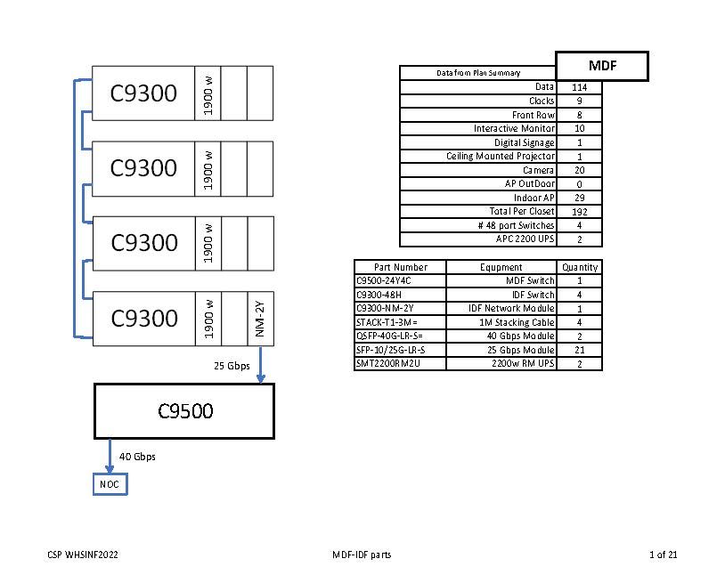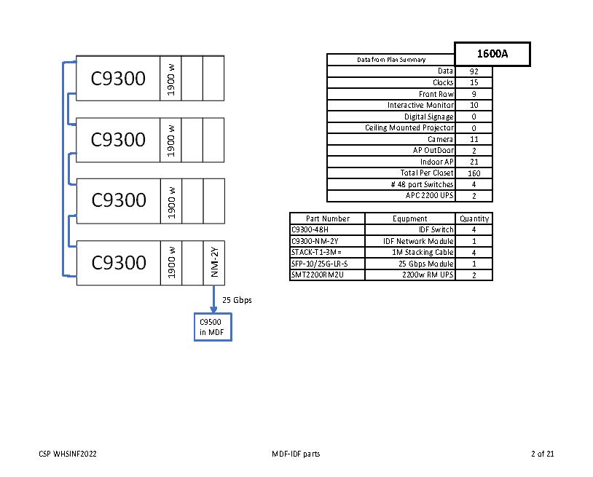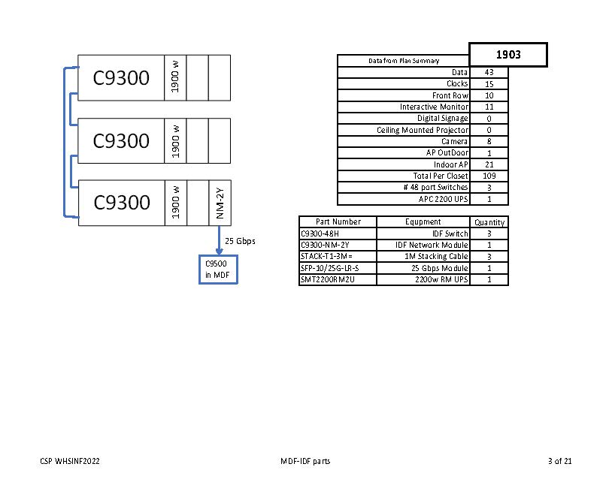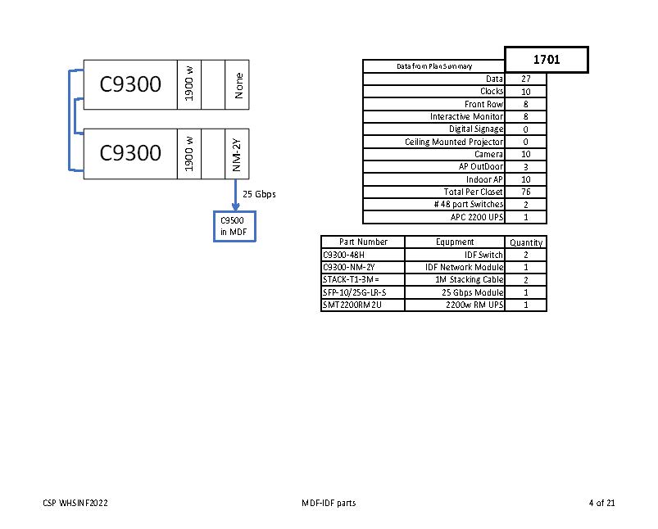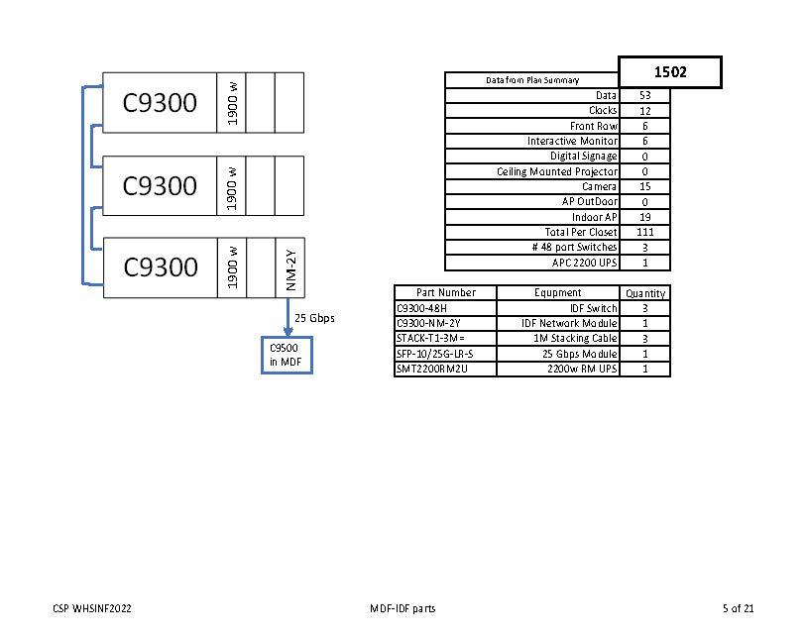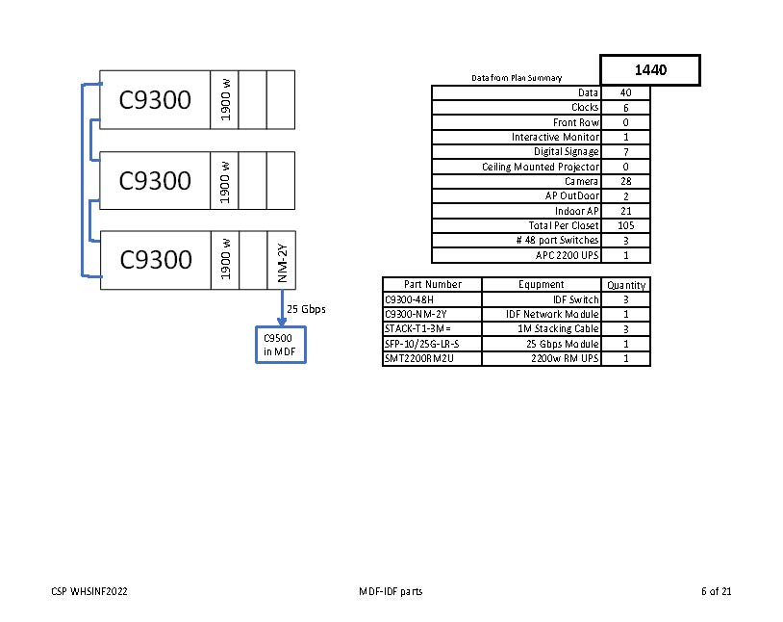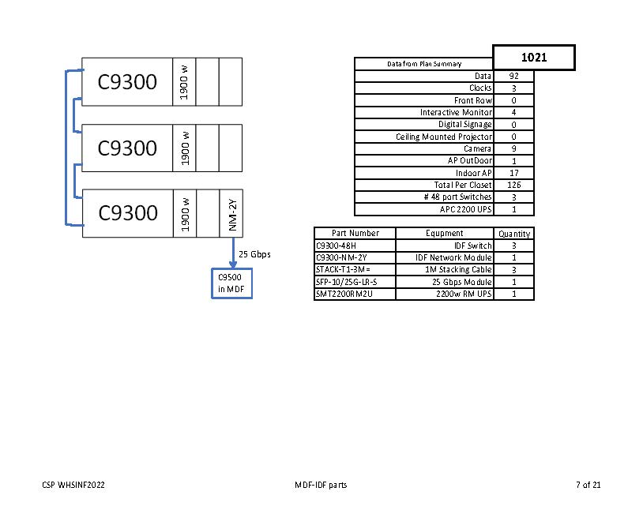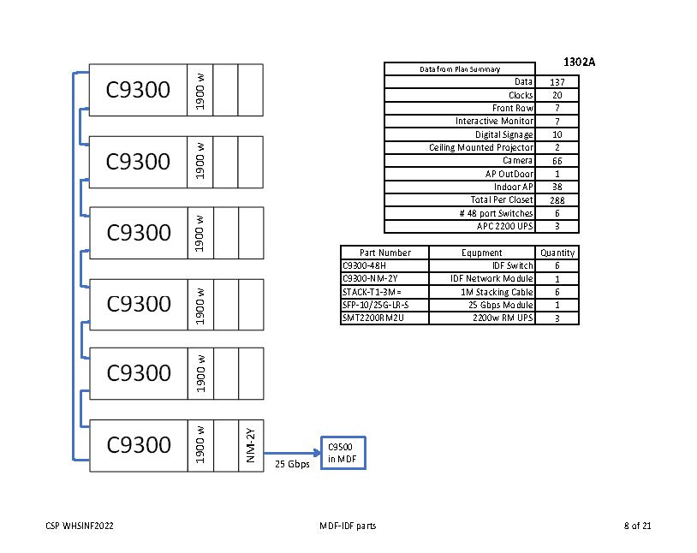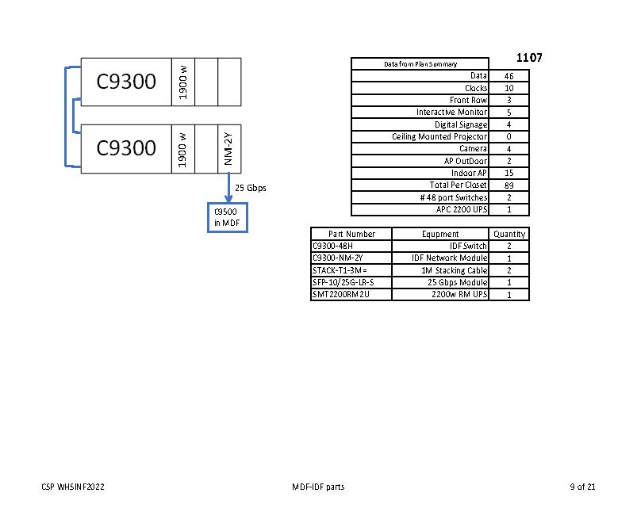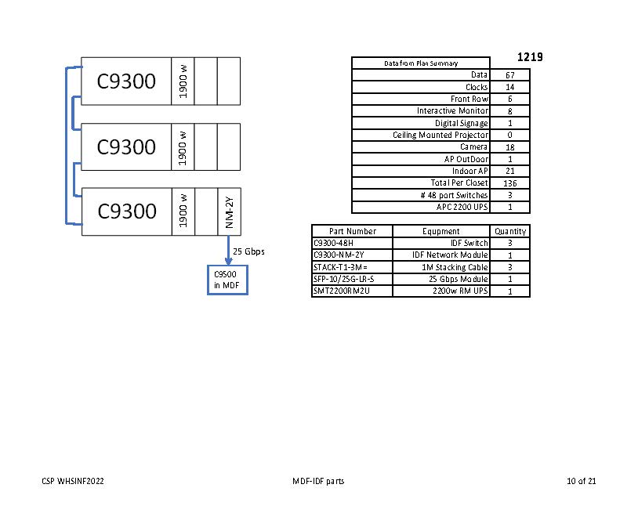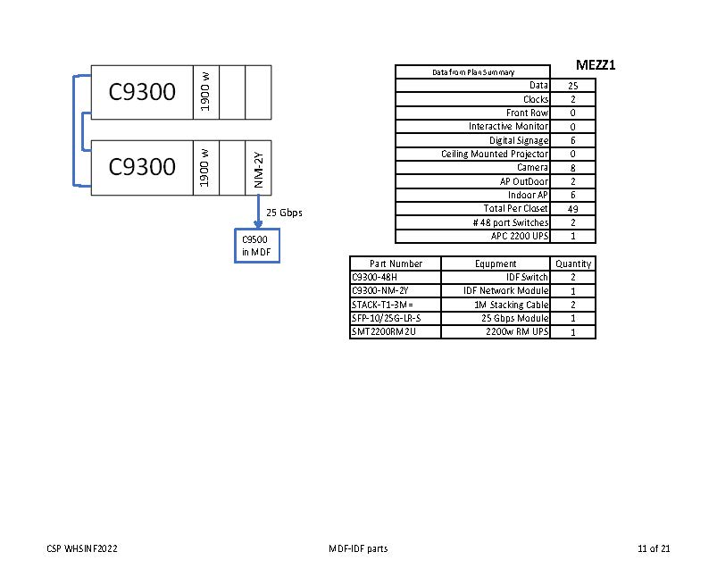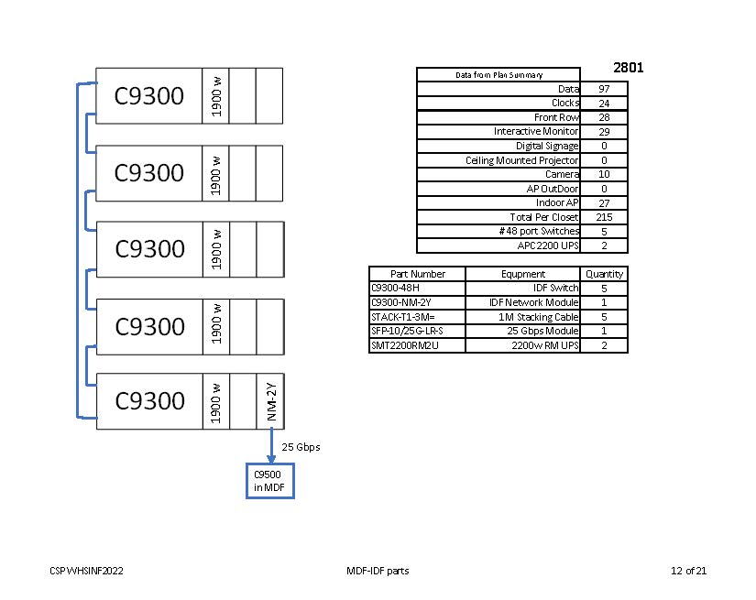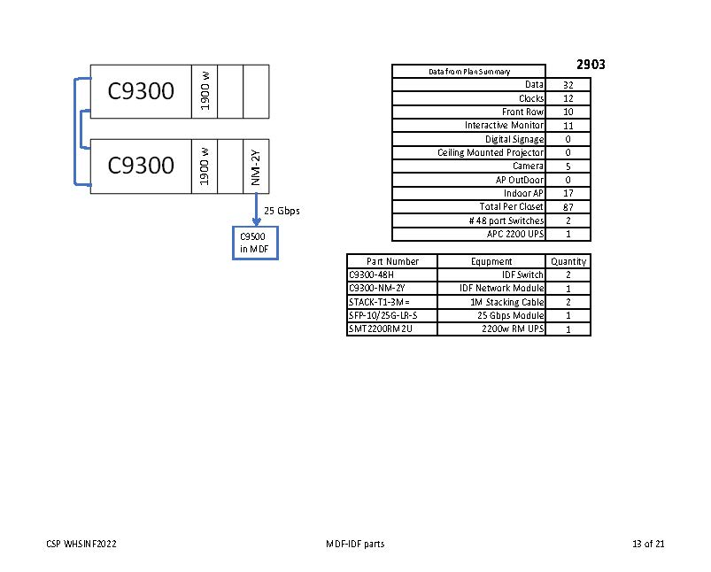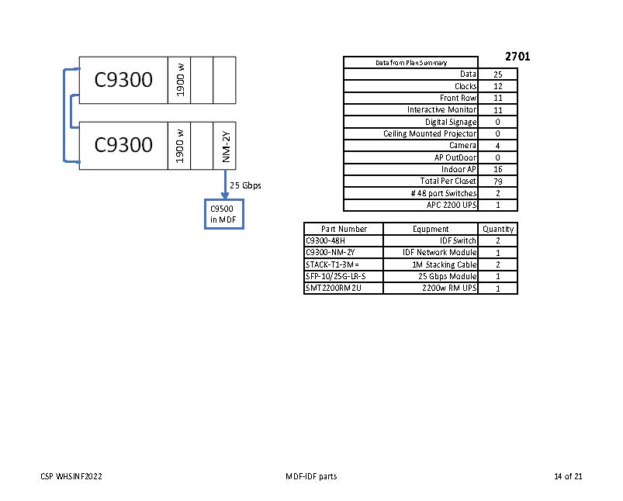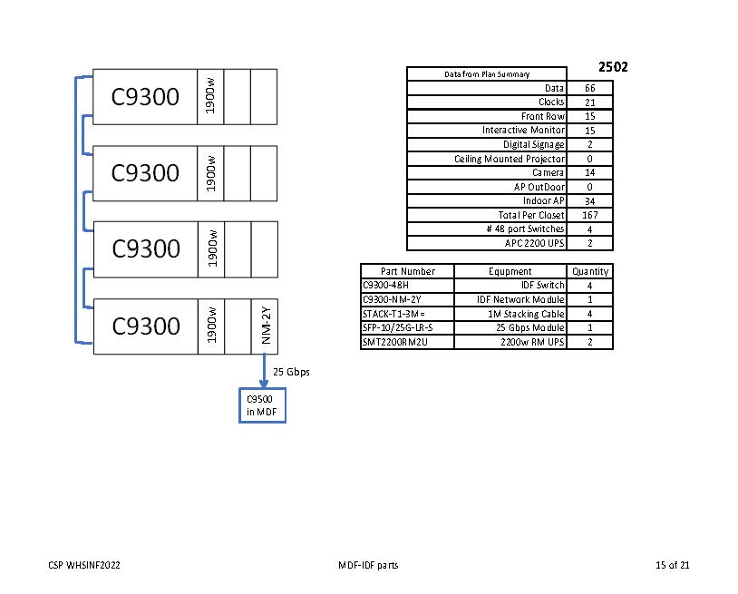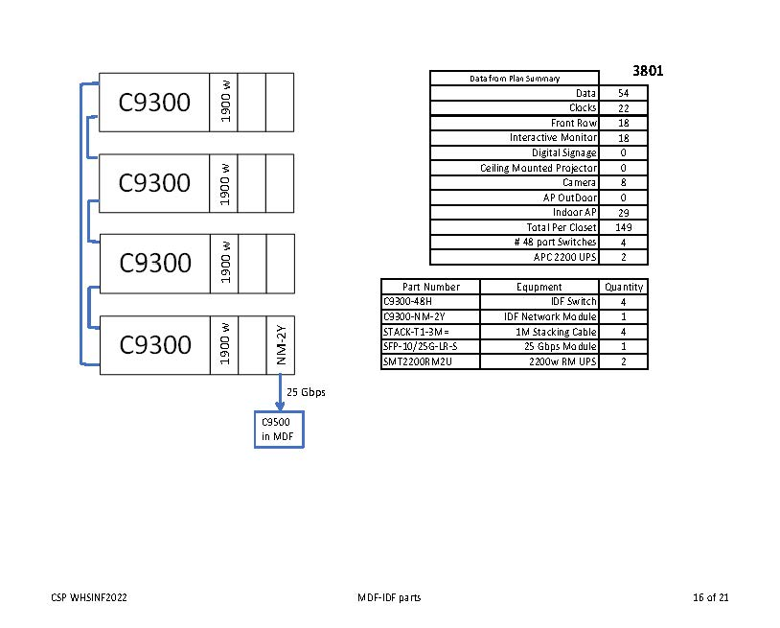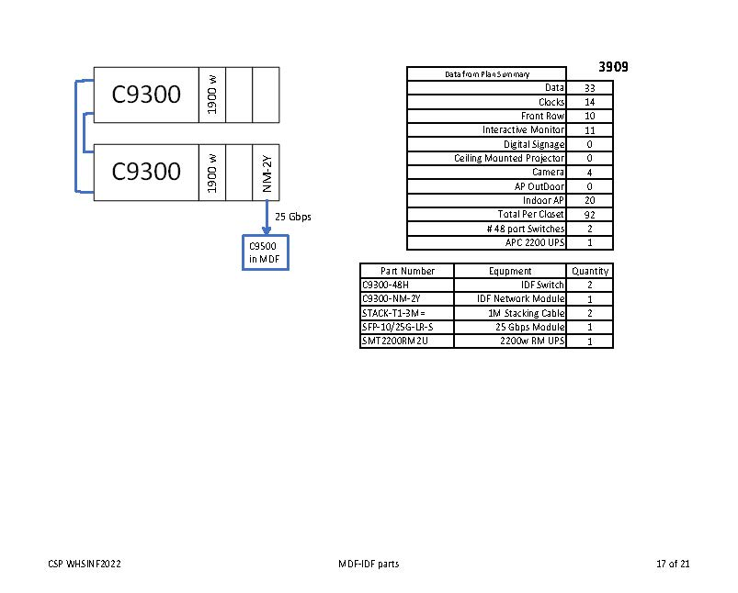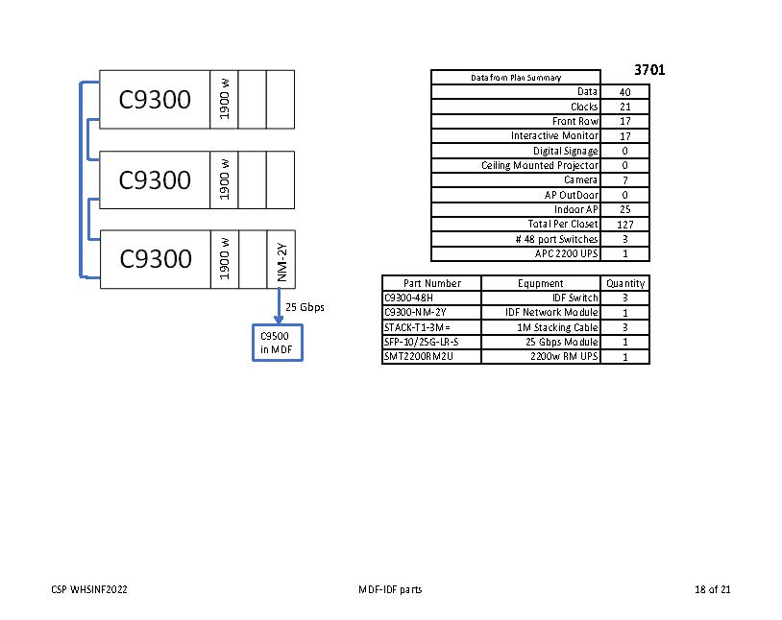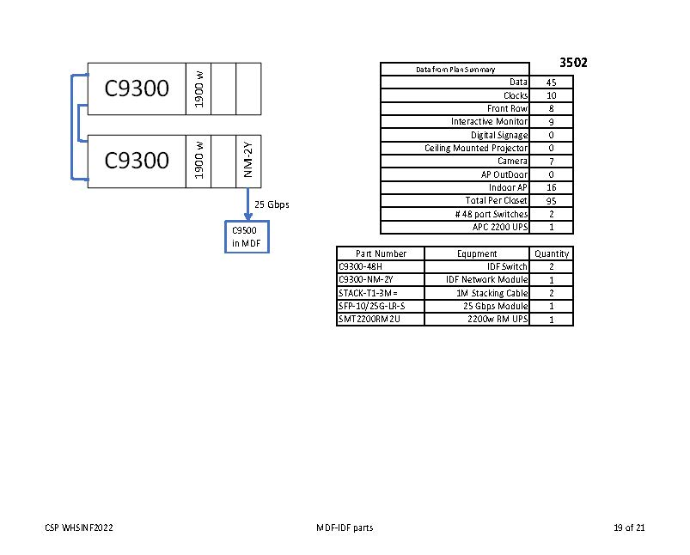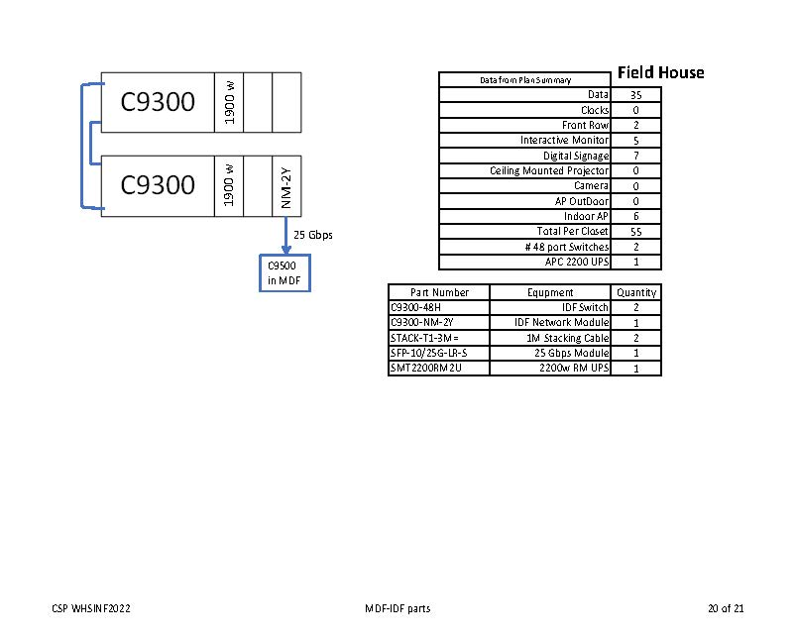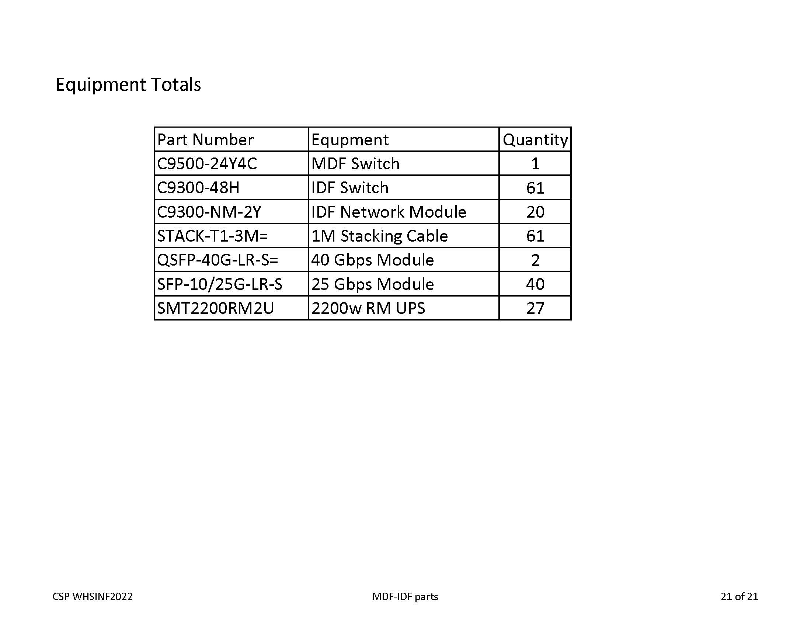
C – Terms and Conditions for E-Rate Procurements and Purchases

The following Terms and Conditions for E-Rate Procurements and Purchases (“E-Rate Terms”) apply to all procurements and purchases involving federal E-Rate funds. These E-Rate Terms are hereby incorporated into and made part of this purchasing solicitation, and by its submission of a bid/proposal, Vendor agrees that these E-Rate Terms are incorporated into and made part of the Agreement and any other contract, purchase order, work order, invoice, order acknowledgement, bid/response/award forms, and/or other commercial documents issued in connection with this purchasing solicitation. In the event of a conflict or inconsistency between or among these E-Rate Terms and this purchasing solicitation, the portion of Vendor’s bid/proposal submitted in response to this purchasing solicitation that is satisfactory to the District, the Agreement, and/or any other contract, purchase order, work order, invoice, order acknowledgement, bid/response/award forms, and/or other commercial documents issued in connection with this purchasing solicitation, these E-Rate Terms shall control.

- This procurement is being conducted in accordance with E-Rate program rules and regulations. The District’s FCC Form 470 associated with this purchasing solicitation may be found at: www.crwconsulting.com/ifcb. The competitive bidding process shall be open and fair, and the District will select the most cost-effective proposal(s), using the price of the eligible products and services as the most heavily-weighted factor, as detailed in the purchasing solicitation.
- Any reference in the purchasing solicitation to a specific manufacturer, brand, product, or service shall mean the referenced manufacturer, brand, product, or service or equivalent.
- Vendor acknowledges that the District will apply for federal E-Rate funding for the Agreement and that the Agreement is contingent upon the District’s receipt of approved E-Rate funding. Vendor agrees to reasonably cooperate with the District in its application for E-Rate funding and to work within the requirements of the E-Rate program, including, without limitation, adhering to all federal gift rules and processing and/or filing all required documentation in a timely manner.
- Vendor represents that it has, and Vendor agrees to maintain for the duration of the Agreement, a valid, non-red light status Service Provider Identification Number (SPIN), as assigned by the Universal Service Administration Company (USAC). Vendor’s SPIN is listed in the signature block below.
- Vendor agrees to provide the Billed Entity Applicant Reimbursement (BEAR) billing method for any purchases under this purchasing solicitation. Vendor further agrees to complete all necessary documentation to facilitate the District’s choice of billing method, including, without limitation, timely filing FCC Form 473 (Service Provider Annual Certification Form), or its equivalent, no later than July 1 of the District’s applicable E-Rate funding year (required for each funding year that Vendor participates in the E-Rate program and for each SPIN) and timely completing FCC Form 473 and the required E-Rate invoicing process to ensure that all invoices and related documentation are signed, certified, and timely submitted in a proper manner (included submitting bills for services with a breakdown of eligible and ineligible services) to be reimbursed.
- In general, the term of the Agreement (including any voluntary extensions) and the service start and end dates under the Agreement shall be July 1 to June 30 of the applicable E-Rate funding year; provided that certain Category One components may be installed prior to July 1 of the applicable E-Rate funding year in order to provide recurring services starting July 1 of the applicable E-Rate funding year, and Category Two services may be installed as early as April 1 preceding the applicable E-Rate funding year and completed as late as September 30 following the applicable E-Rate funding year.
- Vendor agrees that products and services will be installed and delivered as directed by the District and shall be completed as agreed by the District and Vendor, but in any event, (i) recurring services shall be installed and delivered on or before June 30 of the applicable E-Rate funding year; (ii) non-recurring, non-fiber-related services shall be installed and in use on or before September 30 following the applicable E-Rate funding year; and (iii) special construction projects shall be completed, and any fiber shall be lit, on or before June 30 of the applicable E-Rate funding year. Without limiting Vendor’s obligation to comply with the foregoing requirements, if, after performance of the Agreement has begun, Vendor believes that it will be unable to comply the foregoing requirements, Vendor shall notify the District in writing sufficiently in advance of any deadline for the District to file a request for extension, and any request for extension for special construction projects must demonstrate that construction was unavoidably delayed due to weather or other reasons. The District does not guarantee that an extension will be granted.
- The District may voluntarily extend the Agreement for an additional one (1) year term.
- Substitution of sites and services shall be permitted over the life of the Agreement in accordance with the site and service substitution rules found in the HCF Program Order (47 C.F.R. § 54.646: 746 Appendix D, 47 C.F.R. § 54.646) and/or other E-Rate program rules and regulations. Specifically, the District may add products and services within the scope of the purchasing solicitation and the District’s Form 470, and the District may add other locations and/or facilities, to the Agreement in accordance with E-Rate program rules and regulations.
- Vendor shall comply with all federal, state, and local laws, statutes, ordinances, rules, and regulations, including without limitation, E-Rate program rules and regulations, workers’ compensation laws, minimum and maximum salary and wage statutes and regulations, prompt payment and licensing laws and regulations, and the District’s Board Policies. For the duration of the Agreement, Vendor shall maintain all required licenses, certifications, permits, and any other documentation necessary to perform the Agreement. In the event of a conflict or inconsistency between or among any applicable procurement or contract documents, laws, rules, regulations, ordinances, and/or Board Policies, including without limitation, E-Rate rules and regulations, the most stringent requirement shall apply.
- Vendor agrees to maintain all records pertinent to the Agreement for ten (10) years after the later of: (i) the date the District makes final payment and all other pending matters related to the Agreement are closed; or (ii) September 30 of the last E-Rate funding year applicable to the Agreement.

VENDOR HEREBY CERTIFIES ITS AGREEMENT TO THE E-RATE TERMS SET FORTH ABOVE.

Vendor’s Name: ________________________________________________________________
Address, City, State, and Zip Code: _________________________________________________
Phone Number: ____________________________ Fax Number: ______________________
Email Address: ________________________________________________________________
Federal Tax ID # ____________________________ SPIN: ____________________________
Printed Name and Title of Authorized Representative: __________________________________
Signature of Authorized Representative: _____________________________________________
Date: ___________________________

D – PROPOSER/VENDOR CERTIFICATION FORMS

(Please check ALL appropriate boxes below)

CERTIFICATION OF RESIDENCY
The State of Texas has a law concerning nonresident vendors. This law can be found in Texas Government Code under Chapter 2252, Subchapter A. This law makes it necessary for WISD to determine the residency of its Vendors. In part, this law reads as follows:
Section: 2252.001: “‘Nonresident bidder’ refers to a person who is not a resident.” “‘Resident bidder’ refers to a person whose principal place of business is in this state, including a [vendor] whose ultimate parent company or majority owner has its principal place of business in this state.”
Section: 2252.002: “A governmental entity may not award a governmental contract to a nonresident bidder unless the nonresident underbids the lowest bid submitted by a responsible resident bidder by an amount that is not less than the amount by which a resident bidder would be required to underbid the nonresident bidder to obtain a comparable contract in . . . the state in which the nonresident’s principal place of business is located . . . .”
Company submitting bid is a resident bidder: ☐Yes ☐No City and state of Vendor's principal place of business:

MINORITY/WOMEN BUSINESS ENTERPRISE (MWBE) AND HISTORICALLY UNDERUTILIZED BUSINESSES (HUB)
Bidding companies that have been certified by the State of Texas as Historically Underutilized Business (HUB) or Minority/Women Business Enterprise (MWBE) entities are encouraged to indicate their HUB and MWBE status when responding to this purchasing solicitation.
Vendor certifies that this firm is a MWBE (Required by some participating agencies) | - Yes | - No
Vendor certifies that this firm is a HUB (Required by some participating agencies) | - Yes | - No
Please scan a copy of MWBE and/or HUB certification letter and the percentage of your business with MWBE and/or HUB suppliers, if applicable, in your proposal response.

I, the authorized representative for the company named below, certify that the information concerning residency certification, and MWBE and HUB certifications have been reviewed by me and the information furnished is true to the best of my knowledge.

Vendor’s Name/Company Name: ____________________________________________________
Address, City, State, and Zip Code: Phone Number: Fax Number:
Printed Name and Title of Authorized Representative: Email Address:
Signature of Authorized Representative: Date:
CERTIFICATION REGARDING TERRORIST
ORGANIZATIONS

Vendor hereby certifies that it is not a company identified on the Texas Comptroller’s list of companies known to have contracts with, or provide supplies or services to, a foreign organization designated as a Foreign Terrorist Organization by the U.S. Secretary of State.

______ Initials of Authorized Representative of Vendor

CERTIFICATION REGARDING BOYCOTTING OF ISRAEL

If (a) Vendor is not a sole proprietorship; (b) Vendor has ten (10) or more full-time employees; and (c) this Agreement has a value of $100,000 or more, the following certification shall apply; otherwise, this certification is not required. Pursuant to Chapter 2271 of the Texas Government Code, the Vendor hereby certifies and verifies that neither the Vendor, nor any affiliate, subsidiary, or parent company of the Vendor, if any (the “Vendor Companies”), boycotts Israel, and the Vendor agrees that the Vendor and Vendor Companies will not boycott Israel during the term of this Agreement. For purposes of this Agreement, the term “boycott” shall mean and include refusing to deal with, terminating business activities with, or otherwise taking any action that is intended to penalize, inflict economic harm on, or limit commercial relations with Israel, or with a person or entity doing business in Israel or in an Israeli-controlled territory, but does not include an action made for ordinary business purposes.

______ Initials of Authorized Representative of Vendor, if applicable

CERTIFICATION REGARDING CONTRACTING INFORMATION

If Vendor is not a governmental body and (a) this Agreement has a stated expenditure of at least $1 million in public funds for the purchase of goods or services by WISD; or (b) this Agreement results in the expenditure of at least $1 million in public funds for the purchase of goods or services by WISD in a fiscal year of WISD, the following certification shall apply; otherwise, this certification is not required. As required by Tex. Gov’t Code § 552.374(b), the following statement is included in the CSP and the Agreement (unless the Agreement is (1) related to the purchase or underwriting of a public security; (2) is or may be used as collateral on a loan; or (3) proceeds from which are used to pay debt service of a public security of loan): “The requirements of Subchapter J, Chapter 552, Government Code, may apply to this CSP and Agreement and the contractor or vendor agrees that the contract can be terminated if the contractor or vendor knowingly or intentionally fails to comply with a requirement of that subchapter.” Pursuant to Subchapter J, Chapter 552, Texas Government Code, the Vendor hereby certifies and agrees to (1) preserve all contracting information related to this Agreement as provided by the records retention requirements applicable to WISD for the duration of the Agreement; (2) promptly provide to WISD any contracting information related to the Agreement that is in the custody or possession of the Vendor on request of WISD; and (3) on completion of the Agreement, either (a) provide at no cost to WISD all contracting information related to the Agreement that is in the custody or possession of Vendor, or (b) preserve the contracting information related to the Agreement as provided by the records retention requirements applicable to WISD.

______ Initials of Authorized Representative of Vendor, if applicable

CERTIFICATION REGARDING BOYCOTTING CERTAIN ENERGY COMPANIES

If (a) Vendor is not a sole proprietorship; (b) Vendor has ten (10) or more full-time employees; and (c) this Agreement has a value of $100,000 or more that is to be paid wholly or partly from public funds, the following certification shall apply; otherwise, this certification is not required. Pursuant to Tex. Gov’t Code Ch. 2274 of SB 13 (87th session), Vendor hereby certifies and verifies that Vendor, or any wholly owned subsidiary, majority-owned subsidiary, parent company, or affiliate of these entities or business associations, if any, does not boycott energy companies and will not boycott energy companies during the term of the Agreement. For purposes of this Agreement, the term “company” shall mean an organization, association, corporation, partnership, joint venture, limited partnership, limited liability partnership, or limited liability company, that exists to make a profit. The term “boycott energy company” shall mean “without an ordinary business purpose, refusing to deal with, terminating business activities with, or otherwise taking any action intended to penalize, inflict economic harm on, or limit commercial relations with a company because the company (a) engages in the exploration, production, utilization, transportation, sale, or manufacturing of fossil fuel-based energy and does not commit or pledge to meet environmental standards beyond applicable federal and state law, or (b) does business with a company described by paragraph (a).” See Tex. Gov’t Code § 809.001(1).

______ Initials of Authorized Representative of Vendor, if applicable

CERTIFICATION PROHIBITING DISCRIMINATION AGAINST
FIREARM AND AMMUNITION INDUSTRIES

If (a) Vendor is not a sole proprietorship; (b) Vendor has at least ten (10) full-time employees; (c) this Agreement has a value of at least $100,000 that is paid wholly or partly from public funds; (d) the Agreement is not excepted under Tex. Gov’t Code § 2274.003 of SB 19 (87th leg.); and (e) WISD has determined that Vendor is not a sole-source provider or WISD has not received any bids from a company that is able to provide this written verification, the following certification shall apply; otherwise, this certification is not required. Pursuant to Tex. Gov’t Code Ch. 2274 of SB 19 (87th session), Vendor hereby certifies and verifies that Vendor, or association, corporation, partnership, joint venture, limited partnership, limited liability partnership, or limited liability company, including a wholly owned subsidiary, majority-owned subsidiary parent company, or affiliate of these entities or associations, that exists to make a profit, does not have a practice, policy, guidance, or directive that discriminates against a firearm entity or firearm trade association and will not discriminate during the term of this contract against a firearm entity or firearm trade association. For purposes of this Agreement, “discriminate against a firearm entity or firearm trade association” shall mean, with respect to the entity or association, to: “(1) refuse to engage in the trade of any goods or services with the entity or association based solely on its status as a firearm entity or firearm trade association; (2) refrain from continuing an existing business relationship with the entity or association based solely on its status as a firearm entity or firearm trade association; or (3) terminate an existing business relationship with the entity or association based solely on its status as a firearm entity or firearm trade association.” See Tex. Gov’t Code § 2274.001(3) of SB 19. “Discrimination against a firearm entity or firearm trade association” does not include: “(1) the established policies of a merchant, retail seller, or platform that restrict or prohibit the listing or selling of ammunition, firearms, or firearm accessories; and (2) a company’s refusal to engage in the trade of any goods or services, decision to refrain from continuing an existing business relationship, or decision to terminate an existing business relationship to comply with federal, state, or local law, policy, or regulations or a directive by a regulatory agency, or for any traditional business reason that is specific to the customer or potential customer and not based solely on an entity’s or association’s status as a firearm entity or firearm trade association.” See Tex. Gov’t Code § 2274.001(3) of SB 19.

______ Initials of Authorized Representative of Vendor, if applicable

CERTIFICATION REGARDING CERTAIN FOREIGN-OWNED COMPANIES IN CONNECTION WITH CRITICAL INFRASTRUCTURE

WISD is prohibited from entering into a contract or other agreement relating to critical infrastructure that would grant to Vendor direct or remote access to or control of critical infrastructure in this state, excluding access specifically allowed by WISD for product warranty and support purposes. Vendor certifies that neither it nor its parent company nor any affiliate of Vendor or its parent company, is (1) owned by or the majority of stock or other ownership interest of the company is held or controlled by individuals who are citizens of China, Iran, North Korea, Russia, or a designated country; (2) a company or other entity, including governmental entity, that is owned or controlled by citizens of or is directly controlled by the government of China, Iran, North Korea, Russia, or a designated country; or (3) headquartered in China, Iran, North Korea, Russia, or a designated country. For purposes of this Agreement, “critical infrastructure” means “a communication infrastructure system, cybersecurity system, electric grid, hazardous waste treatment system, or water treatment facility.” See Tex. Gov’t Code § 2274.0101(2) of SB 1226 (87th leg.). Vendor verifies and certifies that Vendor will not grant direct or remote access to or control of critical infrastructure, except for product warranty and support purposes, to prohibited individuals, companies, or entities, including governmental entities, owned, controlled, or headquartered in China, Iran, North Korea, Russia, or a designated country, as determined by the Governor.

______Initials of Authorized Representative of Vendor, if applicable

VENDOR AGREES TO COMPLY WITH ALL APPLICABLE FEDERAL, STATE, AND LOCAL LAWS, RULES, REGULATIONS, AND ORDINANCES. IT IS FURTHER ACKNOWLEDGED THAT VENDOR CERTIFIES COMPLIANCE WITH ALL PROVISIONS, LAWS, ACTS, REGULATIONS, ETC. AS SPECIFICALLY NOTED ABOVE.

Vendor’s Name: _______________________________________________________________

Address, City, State, and Zip Code: ________________________________________________

Phone Number: __________________________ Fax Number: ______________________

Printed Name and Title of Authorized Representative: _________________________________

Email Address: _______________________________________________________________

Signature of Authorized Representative: ____________________________________________

Date: ________________________ Federal Tax ID # _________________________________

E – CONFIDENTIALITY DECLARATION FORM

INFORMATION SUBMITTED TO WALLER ISD IN CONNECTION WITH THIS PURCHASING SOLICITATION OR THE AGREEMENT IS GOVERNED BY TEXAS GOVERNMENT CODE, CHAPTER 552

As a governmental body, WISD is subject to the Texas Public Information Act found in Chapter 552, Texas Government Code. Proposals and other information submitted to WISD in connection with this purchasing solicitation or the Agreement may be subject to release as public information. If a Vendor believes that part(s) of its proposal or any other information submitted by Vendor to WISD in connection with this purchasing solicitation or the Agreement contain confidential, proprietary, and/or trade secret information or otherwise may be excepted from disclosure under Texas law, the Vendor must clearly and conspicuously mark the applicable information as “CONFIDENTIAL.”

Marking information as “CONFIDENTIAL” does not guarantee that the information will be withheld from disclosure. If WISD receives a request for public information involving information that Vendor has clearly and conspicuously marked as “CONFIDENTIAL,” WISD will respond pursuant to Chapter 552, Texas Government Code, which may or may not require that WISD provide notice of the request to Vendor. Vendor understands and agrees that it is solely responsible for submitting to the Attorney General of Texas each reason why the requested information should be withheld and a letter, memorandum, or brief in support of that reason. Pursuant to Tex. Gov’t Code § 552.02222, “contracting information” is public and must be released unless excepted from disclosure under Chapter 552. The exceptions provided by Chapter 552 for disclosure for proprietary information (552.1101), commercial or financial information that would cause substantial competitive harm if released (552.110(c)), or trade secrets (552.110(b)) may not be asserted for the following types of contracting information:
- the following contract or offer terms or their functional equivalent: (A) any term describing the overall or total price the governmental body will or could potentially pay, including overall or total value, maximum liability, and final price; (B) a description of the items or services to be delivered with the total price for each if a total price is identified for the item or service in the contract; (C) the delivery and service deadlines; (D) the remedies for breach of contract; (E) the identity of all parties to the contract; (F) the identity of all subcontractors in a contract; (G) the affiliate overall or total pricing for a vendor, contractor, potential vendor, or potential contractor; (H) the execution dates; (I) the effective dates; and (J) the contract duration terms, including any extension options; or
- information indicating whether a vendor, contractor, potential vendor, or potential contractor performed its duties under a contract, including information regarding: (A) a breach of contract; (B) a contract variance or exception; (C) a remedial action; (D) an amendment to a contract; (E) any assessed or paid liquidated damages; (F) a key measures report; (G) a progress report; and (H) a final payment checklist.

WISD assumes no obligation or responsibility relating to the disclosure or nondisclosure of information submitted by Vendors, and Vendor hereby waives any claim against and releases from liability WISD, its respective officers, employees, agents, and attorneys with respect to disclosure of information provided under or in connection with this purchasing solicitation or the Agreement or otherwise created, assembled, maintained, or held by Vendor or WISD and determined by WISD, the Attorney General of Texas, or a court of law to be subject to disclosure under the Texas Public Information Act. Further, even if Vendor marks information as “CONFIDENTIAL,” Vendor expressly agrees that WISD may disclose Vendor’s proposal, including, but not limited to, pricing information, to other governmental entities.

Please check ONLY ONE of the following options:

- Declaration of Confidentiality – Vendor HAS clearly and conspicuously marked information contained in its proposal and/or other information submitted by Vendor to WISD in connection with this purchasing solicitation or the Agreement as “CONFIDENTIAL.” Vendor declares that the information marked by Vendor as “CONFIDENTIAL” contains confidential, proprietary, and/or trade secret information and is excepted from disclosure under Chapter 552, Texas Government Code.

- Waiver of Confidentiality – Vendor HAS NOT marked any information contained in its proposal and/or other information submitted by Vendor to WISD in connection with this purchasing solicitation or the Agreement as “CONFIDENTIAL.” Vendor certifies that it has not submitted any confidential, proprietary, and/or trade secret information to WISD and that its proposal and all other information—including any pricing information—submitted by Vendor to WISD in connection with this purchasing solicitation or the Agreement is subject to disclosure under Chapter 552, Texas Government Code. Vendor hereby expressly waives any claim of confidentiality with respect to its proposal and/or any other information submitted by Vendor to WISD in connection with this purchasing solicitation or the Agreement.

___________________________________
Vendor Name

___________________________________
Printed Name of Authorized Officer/Representative of Vendor

___________________________________
Title

___________________________________ ___________________
Signature Date

F – ANTITRUST CERTIFICATION STATEMENT
(Tex. Government Code § 2155.005)

I affirm under penalty of perjury of the laws of the State of Texas that:
- I am duly authorized to execute this contract on my own behalf or on behalf of the company, corporation, firm, partnership or individual (Company) listed below;
- In connection with this bid, neither I nor any representatives of the Company have violated any provision of the Texas Antitrust laws codified in Tex. Bus. & Comm. Code Chapter 15;
- In connection with this bid, neither I nor any representative of the Company have violated any federal antitrust law; and
- Neither I nor any representatives of the Company have directly or indirectly communicated any of the contents of this bid to a competitor of the Company or any other company, corporation, firm, partnership or individual engaged in the same line of business as the Company.

Vendor’s Name/Company Name:

Address, City, State, and Zip Code:

Bidder Signature:

Printed Name:

Title: Date Signed:

Signature of Company Official Authorizing CSP:

Printed Name of Company Official:

Official Position: Date Signed:

G – FELONY CONVICTION NOTICE FORM

FELONY CONVICTION NOTIFICATION

State of Texas Legislative Senate Bill No. 1 Section 44.034, Notification of Criminal History, Subsection (a), states “a person or business entity that enters into an agreement with a school district must give advance notice to the district if the person or an owner or operator of the business entity has been convicted of a felony. The notice must include a general description of the conduct resulting in the conviction of a felony”.
Subsection (b) states “a school district may terminate the agreement with a person or business entity if the district determines that the person or business entity failed to give notice as required by Subsection (a), or misrepresented the conduct resulting in the conviction. The district must compensate the person or business entity for services performed before the termination of the contract”.
Subsection (c) states “this section does not apply to a publicly held corporation”.

I, the undersigned agent for the firm named below, certify that the information concerning notification of felony convictions has been reviewed by me and the information furnished is true to the best of my knowledge.

Vendor’s Name/Company Name:
Authorized Official’s Name (Printed or Typed):
You must select one and sign below:
☐ Firm is a publicly held corporation; therefore the above reporting requirement does not apply per Section 44.034, Texas Education Code, Subsection (c).
☐ Vendor/Firm is not owned nor operated by anyone who has been convicted of a felony.
☐ Vendor/Firm is operated or owned by the following individual(s) who has/have been convicted of a felony:

Name of Individual(s):
Detail of Conviction(s):
(Attach additional pages if necessary.)

Signature of Company Official:

Date: _____

H – Ch. 22 Criminal History Records Contractor Certification: Contractor/Subcontractor Employees

Background: Texas Education Code Chapter 22 requires that criminal history records be obtained regarding covered employees of entities that contract with school districts (“Contractors”) and entities that contract with school district contractors (“Subcontractors”). Covered employees with disqualifying criminal histories are prohibited from serving at a school district. Contractors shall (1) complete this form certifying compliance with the requirements of Texas Education Code Chapter 22 to WISD; and (2) provide a copy of this form to each subcontractor for completion certifying compliance with the requirements of Texas Education Code Chapter 22 to WISD and Contractor.

Criminal history records will be obtained by either the Contractor/Subcontractor or WISD, as follows:
- Contractor/Subcontractor: Pursuant to guidance from the Texas Education Agency, the only contractors/subcontractors who will be granted access to fingerprint criminal history are those who qualify for access under the National Child Protection Act (NCPA), specifically, those contractors/subcontractors who provide “care or care placement services” and are based in Texas. All entities qualifying for access under the NCPA are required to obtain their covered employees’ criminal histories, certify compliance to WISD (and, in the case of a Subcontractor, certify compliance to Contractor and WISD), and obtain similar certifications from their subcontractors. For more information or to set up an account, a contractor/subcontractor should contact the Texas Department of Public Safety’s Crime Records Service at 512.424.2474.
- WISD: All entities who do not qualify for access to fingerprint criminal history under the NCPA (in other words, all contractors/subcontractors who do not provide “care or care placement services” or are not based in Texas) are required to follow the instructions listed below, so that WISD may obtain their covered employees’ criminal histories, as applicable. Contractor/Subcontractor is responsible for the payment of all fingerprinting costs. Should WISD pay any costs of fingerprinting Contractor/Subcontractor employees, Contractor agrees to reimburse WISD for such costs; in the event Contractor fails to reimburse WISD for the costs of fingerprinting Contractor/Subcontractor employees, Contractor agrees that WISD may deduct such costs from any payment due and owing by WISD to Contractor.

Definitions:

Covered employees: Employees of a contractor/subcontractor who have or will have continuing duties related to the service to be performed at a school district and have or will have direct contact with students. WISD will be the final arbiter of what constitutes continuing duties and direct contact with students.

Continuing duties related to contracted services: Work duties that are performed pursuant to a contract to provide services to a school entity on a regular, repeated basis rather than infrequently or one-time only. See 19 Tex. Admin. Code §153.1101(2).

Direct contact with students: The contact that results from activities that provide substantial opportunity for verbal or physical interaction with students that is not supervised by a certified educator or other professional district employee. Contact with students that results from services that do not provide substantial opportunity for unsupervised interaction with a student or students, such as addressing an assembly, officiating a sports contest, or judging an extracurricular event, is not, by itself, direct contact with students. However, direct contact with students does result from any activity that provides substantial opportunity for unsupervised contact with students, which might include, without limitation, the provision of coaching, tutoring, or other services to students. See 19 Tex. Admin. Code §153.1101(7).

Public Works Exception to Covered Employees: Covered employees do not include employees of a contracting or subcontracting entity that is providing engineering, architectural, or construction services on a project to design, construct, alter, or repair a public work if: (1) the public work does not involve the construction, alteration, or repair of an instructional facility as defined by Texas Education Code Section 46.001; (2) the employee’s duties will be completed more than seven (7) days before a new instructional facility will be used for instruction; or (3) for an existing instructional facility, the work area contains sanitary facilities separated from all areas used by students by a fence at least six (6) feet high, and the Contractor adopts, informs employees of, and enforces a policy prohibiting employees and any subcontractor’s employees from interacting with students or entering areas used by students.

Disqualifying criminal history:
- For employees of a contracting or subcontracting entity that is providing engineering, architectural, or construction services on a project to design, construct, alter, or repair a public work: (1) a conviction or other criminal history information designated by WISD; (2) a felony or misdemeanor offense that would prevent a person from being employed under Texas Education Code § 22.08341(d), that is: conviction during the preceding 30 years (if at the time of the offense, the victim was under 18 or was enrolled in a public school) of: (a) a felony offense under Title 5, Texas Penal Code; (b) an offense on conviction of which a defendant is required to register as a sex offender under Chapter 62, Texas Code of Criminal Procedure; or (c) an offense under federal law or the laws of another state that is equivalent to (a) or (b).
- For employees of all other contracting or subcontracting entities: (1) a conviction or other criminal history information designated by WISD; (2) a felony or misdemeanor offense that would prevent a person from being employed under Texas Education Code § 22.085(a), that is: (a) conviction of a felony offense under Title 5, Texas Penal Code if at the time of the offense, the victim was under 18; (b) conviction of or placement on deferred adjudication community supervision for an offense for which a defendant is required to register as a sex offender under Chapter 62, Texas Code of Criminal Procedure; or (c) conviction of an offense under federal law or the laws of another state that is equivalent to (a) or (b).

Types of Criminal History Record Information:
- For employees hired by Contractor/Subcontractor before January 1, 2008—Any law enforcement or criminal justice agency.
- For employees hired by Contractor/Subcontractor on or after January 1, 2008—National criminal history information from the Texas Department of Public Safety criminal history clearinghouse.
On behalf of (“Contractor/Subcontractor”), I, the undersigned authorized signatory for Contractor/Subcontractor, certify to Waller Independent School District (“WISD”) (and, in the case of a Subcontractor, certify to Contractor and WISD) that [check one]:

[ ] None of the employees of Contractor/Subcontractor are covered employees, as defined above. If this box is checked, I further certify that Contractor/Subcontractor has taken precautions or imposed conditions to ensure that its employees will not become covered employees. Contractor/Subcontractor will maintain these precautions or conditions throughout the time the contracted services are provided. If WISD, in its sole discretion, determines that employees of Contractor/Subcontractor are covered employees, as defined above, Contractor/Subcontractor will provide WISD with the name, date of birth, and any other requested information of such covered employees so that WISD may obtain criminal history record information on the covered employees, upon request of WISD.
Or
[ ] Some or all of the employees of Contractor/Subcontractor are covered employees, and Contractor/ Subcontractor qualifies for access to fingerprint criminal history under the National Child Protection Act. If this box is checked, I further certify that:
      - Contractor/Subcontractor has obtained all required criminal history record information regarding its covered employees. None of the covered employees has a disqualifying criminal history.
      - If Contractor/Subcontractor receives information that a covered employee subsequently has a reported criminal history, Contractor/Subcontractor will immediately remove the covered employee from contract duties and notify WISD in writing within 3 business days.
      - Upon request, Contractor/Subcontractor will provide WISD with the name, date of birth, and any other requested information of covered employees so that WISD may obtain criminal history record information on the covered employees.
Or
[ ] Some or all of the employees of Contractor/Subcontractor are covered employees, and Contractor/Subcontractor does not qualify for access to fingerprint criminal history under the National Child Protection Act. If this box is checked, I further certify that:

- For all covered employees hired by Contractor/Subcontractor before January 1, 2008, Contractor/Subcontractor has obtained all required criminal history record information. None of the covered employees has a disqualifying criminal history. If Contractor/Subcontractor receives information that a covered employee subsequently has a reported criminal history, Contractor/Subcontractor will immediately remove the covered employee from contract duties and notify WISD in writing within 3 business days. Upon request, Contractor/Subcontractor will provide WISD with the name, date of birth, and any other requested information of covered employees so that WISD may obtain criminal history record information on the covered employees.
- For each covered employee hired by Contractor/Subcontractor on or after January 1, 2008, Contractor/Subcontractor has attached a separate page(s) listing the following information regarding each covered employee, so that WISD may obtain the covered employees’ criminal history record information: (a) Full name (first, middle, and last); and (b) Date of birth.
- Contractor/Subcontractor shall provide WISD’s “Texas Fingerprint Service Code Form” document to all covered employees and ensure that they schedule fingerprinting appointments in a timely manner. Any covered employee whose criminal history record information is not received by WISD at least ten (10) WISD business days prior to the start of the services to be performed by Contractor/Subcontractor at WISD is subject to exclusion from service, in WISD’s sole discretion, until his or her criminal history record information can be obtained and reviewed by WISD. Contractor/Subcontractor is responsible for the payment of all fingerprinting costs. In accordance with the Texas Education Agency guidance, because Contractor/Subcontractor does not qualify for access to fingerprint criminal history under the NCPA, it will not be permitted to view the criminal history record information from DPS.
- Contractor/Subcontractor agrees that WISD will review each covered employee’s criminal history record information, together with the employee’s qualifications, background, and experience, based on information gathered by WISD through the procurement and/or contracting processes, to determine, in WISD’s sole discretion, whether any covered employee(s) should be prohibited from serving at WISD. WISD will notify Contractor/Subcontractor of its determination.
- If WISD at any time receives information that a covered employee subsequently has a reported disqualifying criminal history or should be prohibited from serving at WISD, in WISD’s sole discretion, for any other reason, including, but not limited to, the employee’s qualifications, background, and experience, based on information gathered by WISD through the procurement and/or contracting processes, WISD will notify Contractor/Subcontractor of its determination. Contractor/Subcontractor will immediately remove the covered employee from contract duties.

If WISD, in its sole discretion, objects to the assignment of a covered employee for any reason, including, but not limited to, on the basis of the covered employee’s criminal history record information and/or insufficient qualifications, lack of experience, and the like, based on information gathered by WISD through the procurement and/or contracting processes, Contractor/Subcontractor agrees to discontinue using that covered employee to provide services at WISD.

I also certify to WISD (and, in the case of a Subcontractor, certify to Contractor and WISD) on behalf of Contractor/Subcontractor that Contractor/Subcontractor has required its subcontractors to comply with Texas Education Code, Chapter 22 and obtained certifications from its subcontractors of such compliance. Noncompliance or misrepresentation regarding this certification may be grounds for contract termination.

Signature Title Date

*** Upon contract award and/or initiation of PO/contract from WISD, the winning proposer/Contractor will be provided WISD’s service code form to have its and its subcontractors’ covered employees fingerprinted.

I – WISD CONFLICT OF INTEREST DISCLOSURE STATEMENT
Waller Independent School District (WISD) is required to comply with Texas Local Government Code Chapter 176, Disclosure of Certain Relationships with Local Government Officers. House Bill 23 significantly changed Chapter 176 as well as the required disclosures and the corresponding forms. As of September 1, 2015, any vendor who does business with WISD or who seeks to do business with WISD must fill out the new Conflict of Interest Questionnaire (CIQ) whether or not a conflict of interest exists. A conflict of interest exists in the following situations:
- If the vendor has an employment or other business relationship with a local government officer of WISD or a family member of the officer, as described by section 176.003(a)(2)(A) of the Texas Local Government Code; or
- If the vendor has given a local government officer of WISD, or a family member of the officer, one or more gifts with the aggregate value of $100, excluding any gift accepted by the officer or a family member of the officer if the gift is: (a) a political contribution as defined by Title 15 of the Election Code; or (b) a gift of food accepted as a guest; or
- If the vendor has a family relationship with a local government officer of WISD.

“Vendor” means a person who enters or seeks to enter into a contract with a local governmental entity. The term includes an agent of a vendor. The term includes an officer or employee of a state agency when that individual is acting in a private capacity to enter into a contract. The term does not include a state agency except for Texas Correctional Industries. Texas Local Government Code 176.001(7).

“Business relationship” means a connection between two or more parties based on commercial activity of one of the parties. The term does not include a connection based on: (A) a transaction that is subject to rate or fee regulation by a federal, state, or local governmental entity or an agency of a federal, state, or local governmental entity; (B) a transaction conducted at a price and subject to terms available to the public; or (C) a purchase or lease of goods or services from a person that is chartered by a state or federal agency and that is subject to regular examination by, and reporting to, that agency. Texas Local Government Code 176.001(3).

“Family relationship” means a relationship between a person and another person within the third degree by consanguinity or the second degree by affinity, as those terms are defined by Subchapter B, Chapter 573, Government Code. Texas Local Government Code 176.001(2-a).

“Local government officer” means: (A) a member of the governing body of a local governmental entity; (B) a director, superintendent, administrator, president, or other person designated as the executive officer of a local governmental entity; or (C) an agent of a local governmental entity who exercises discretion in the planning, recommending, selecting, or contracting of a vendor. Texas Local Government Code 176.001(4).

- WISD Board of Trustees and Superintendent include:
David Kaminski, Board President Maria Herrera, Board Vice President
William Warren Board Secretary Gary Buchanan, Board Member
Ronald Campbell, Board Member Bryan Lowe, Board Member
Dr. Michael W. Prince, Board Member Kevin Moran, Superintendent

- Current local government officers include, but are not limited to:
Audrey Ambridge, Chief Financial Officer
Rosa Ojeda, Chief Information Officer
Karen Hackler, Bids/Purchasing Specialist
[INSERT OTHERS - any agent of a local governmental entity who exercises discretion in the planning, recommending, selecting, or contracting of a vendor]

If no conflict of interest exists, you must fill out Box 1 and type N/A on Box 3 of the CIQ form, sign and date it. In the event of changed circumstances, an updated CIQ must be filed within seven (7) business days after Vendor becomes aware that a conflict of interest exists.

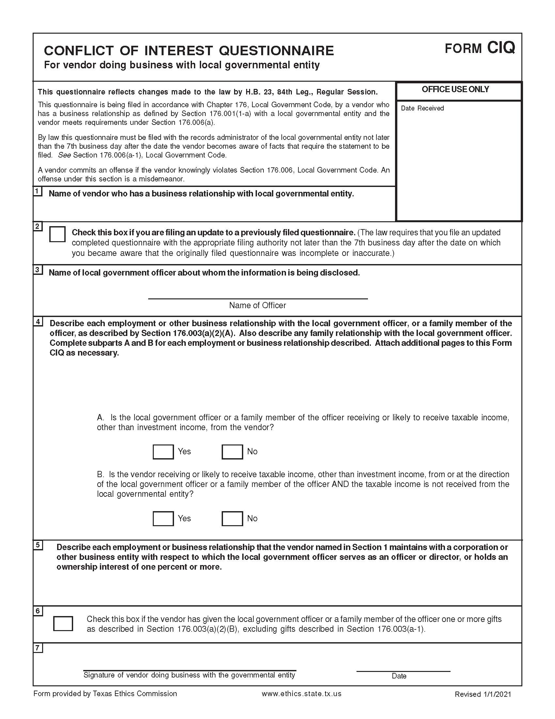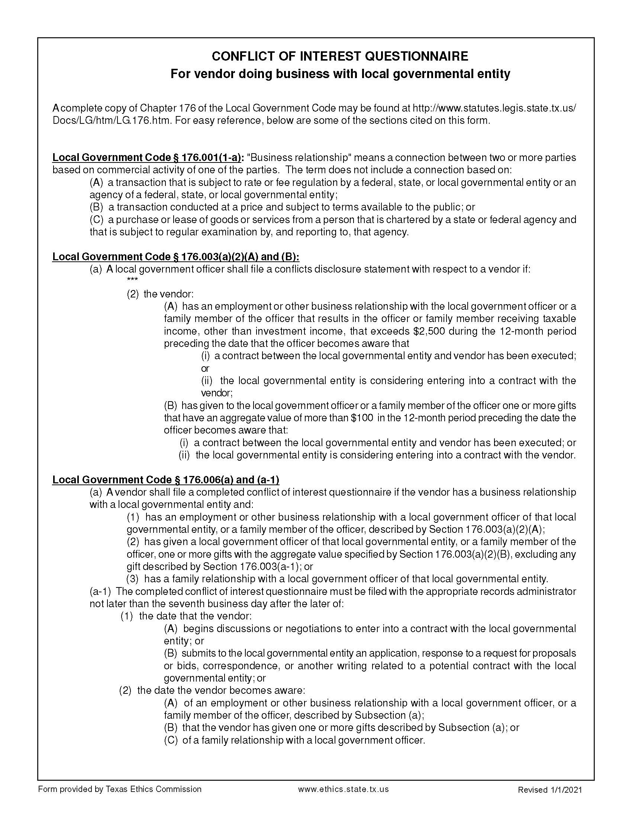

J – WISD CERTIFICATE OF INTERESTED PARTIES – FORM 1295

WISD is required to comply with HB 1295, which amended the Texas Government Code by adding Section 2252.908, Disclosure of Interested Parties. Section 2252.908 applies to a contract of WISD that (1) requires an action or vote by the WISD Board of Trustees before the contract may be signed; (2) has a value of at least $1 million; or (3) is for services that would require a person to register as a lobbyist under Tex. Gov’t Code Chapter 305. If applicable, the business entity must submit a Disclosure of Interested Parties (Form 1295) to WISD at the time business entity submits the signed contract. The Form 1295 requirement does not apply to: (1) a contract with a publicly traded business entity or wholly owned subsidiary of the same; (2) an electric utility; or (3) a gas utility. The Texas Ethics Commission has adopted rules requiring the business entity to file Form 1295 electronically with the Texas Ethics Commission. The following definitions apply:

- “Business Entity” means an entity recognized by law through which business is conducted, including a sole proprietorship, partnership, or corporation. Tex. Gov’t Code § 2252.908(1).

- “Interested Party” means a person:
- who has a controlling interest in a business entity with whom WISD contracts; or
- who actively participates in facilitating the contract or negotiating the terms of the contract, including a broker, intermediary, adviser, or attorney for the business entity. Tex. Gov’t Code § 2252.908(3).

- “Controlling interest” means:
- an ownership interest or participating interest in a business entity by virtue of units, percentage, shares, stock, or otherwise that exceeds 10 percent;
- membership on the board of directors or other governing body of a business entity of which the board or other governing body is composed of not more than 10 members; or
- service as an officer of a business entity that has four or fewer officers, or service as one of the four officers most highly compensated by a business entity that has more than four officers. Subsection (c) does not apply to an officer of a publicly held business entity or its wholly owned subsidiaries. Tex. Ethics Comm. Rule 46.3(c).

- “Intermediary” means a person who actively participates in the facilitation of the contract or negotiating the contract, including a broker, adviser, attorney, or representative of or agent for the business entity who:
- receives compensation from the business entity for the person’s participation;
- communicates directly with the governmental entity or state agency on behalf of the business entity regarding the contract; and
- is not an employee of the business entity. Tex. Ethics Comm. Rule 46.3(e).

As a “business entity,” vendors must:
- complete Form 1295 electronically with the Texas Ethics Commission using the online filing application, which can be found at https://www.ethics.state.tx.us/whatsnew/elf_info_form1295.htm
- All vendors must complete Form 1295, even if no interested parties exist
- In Section 2, insert “Waller Independent School District”
- In Section 3, insert the WISD CSP # for this proposal
- print a copy of the completed form (make sure that it has a computer-generated certification number in the “Office Use Only” box)
- have an authorized agent of the business entity sign the form
- submit the completed Form 1295 by attaching the form to your proposal in the Response Attachments section of the WISD eBid System.
WISD must acknowledge the receipt of the filed Form 1295 by notifying the Texas Ethics Commission of the receipt of the filed Form 1295 no later than the 30th day after receipt. After WISD acknowledges the Form 1295, the Texas Ethics Commission will post the completed Form 1295 to its website with seven business days after receiving notice from WISD.
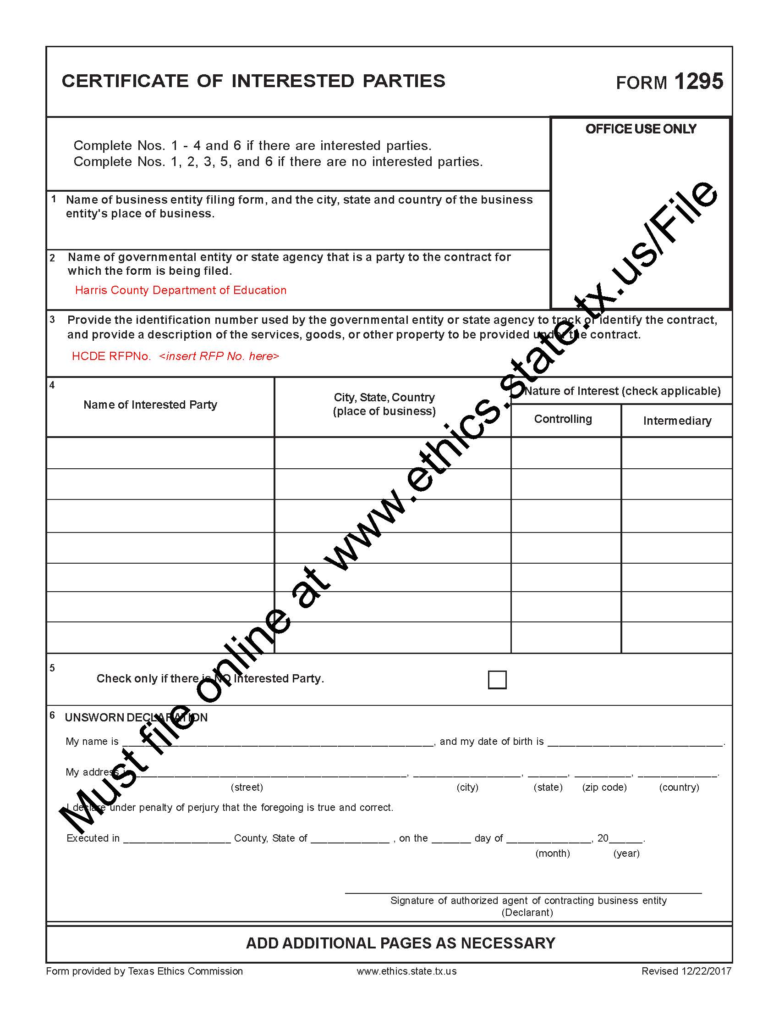
WISD CSP No.: CSP WHSINF2022
Waller Independent School District

K – IRS FORM W-9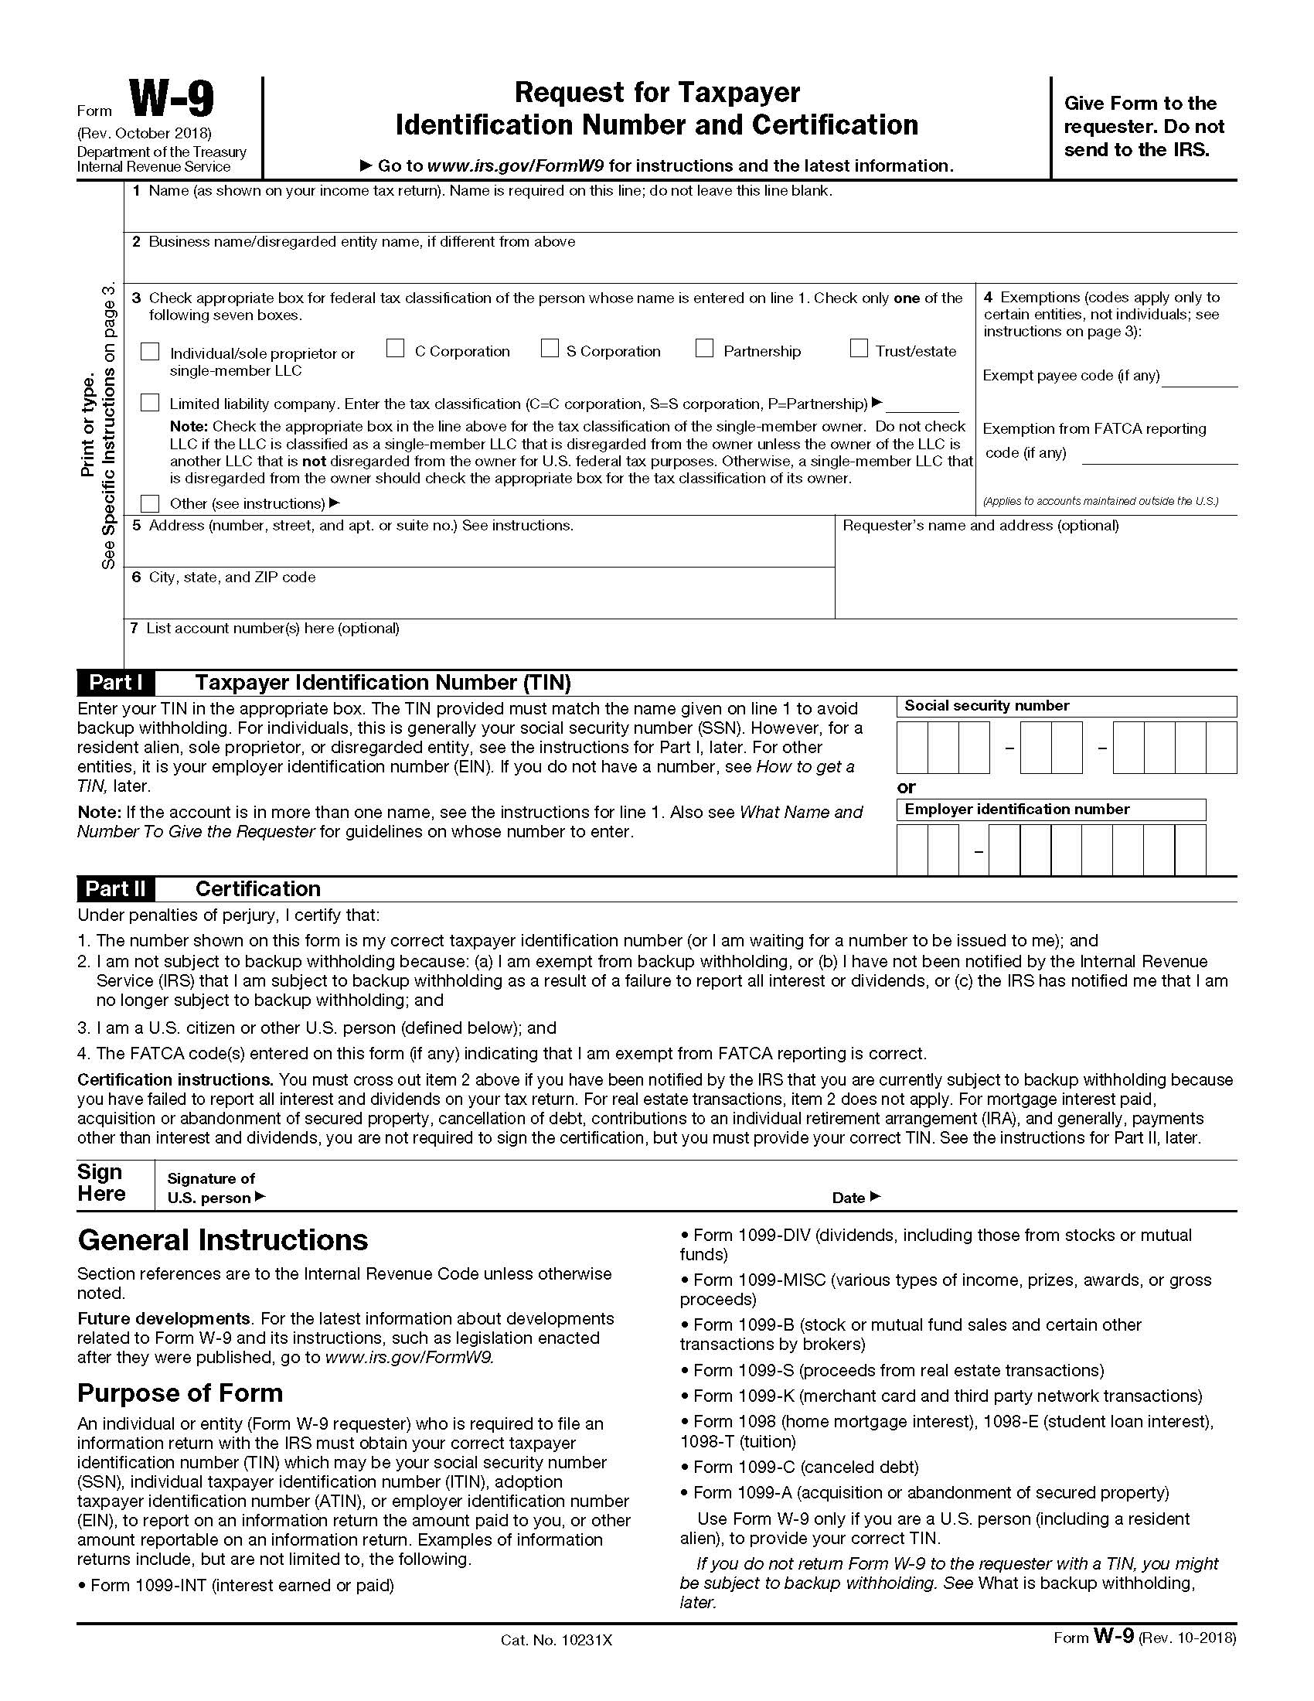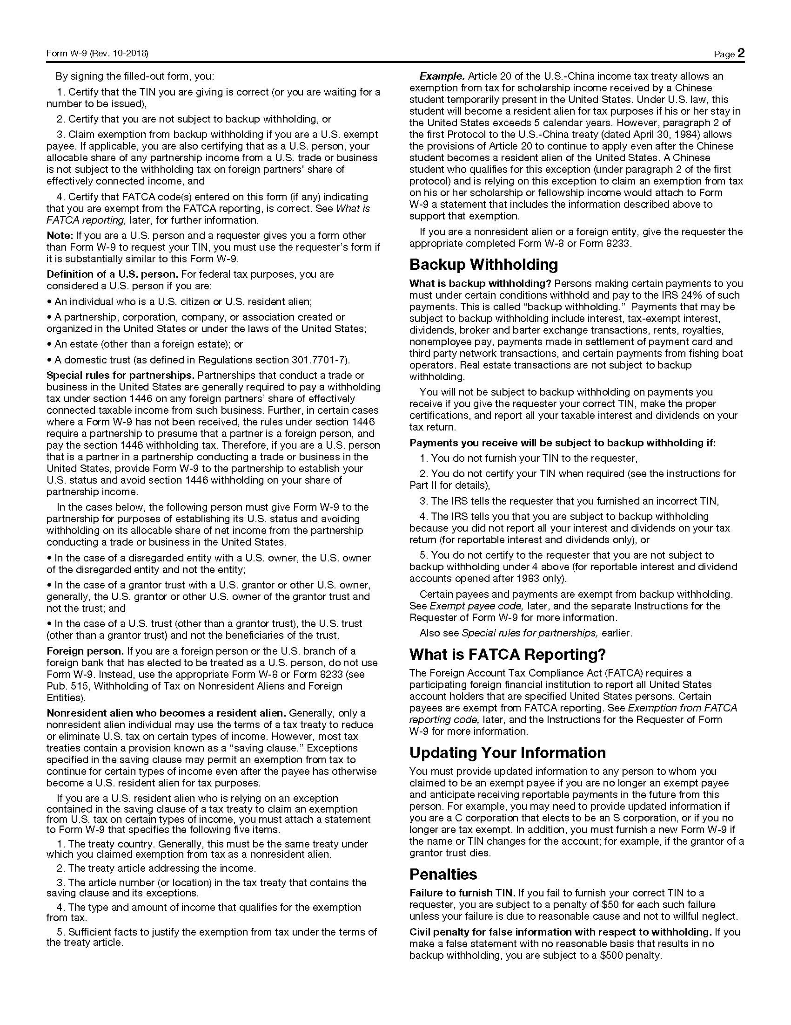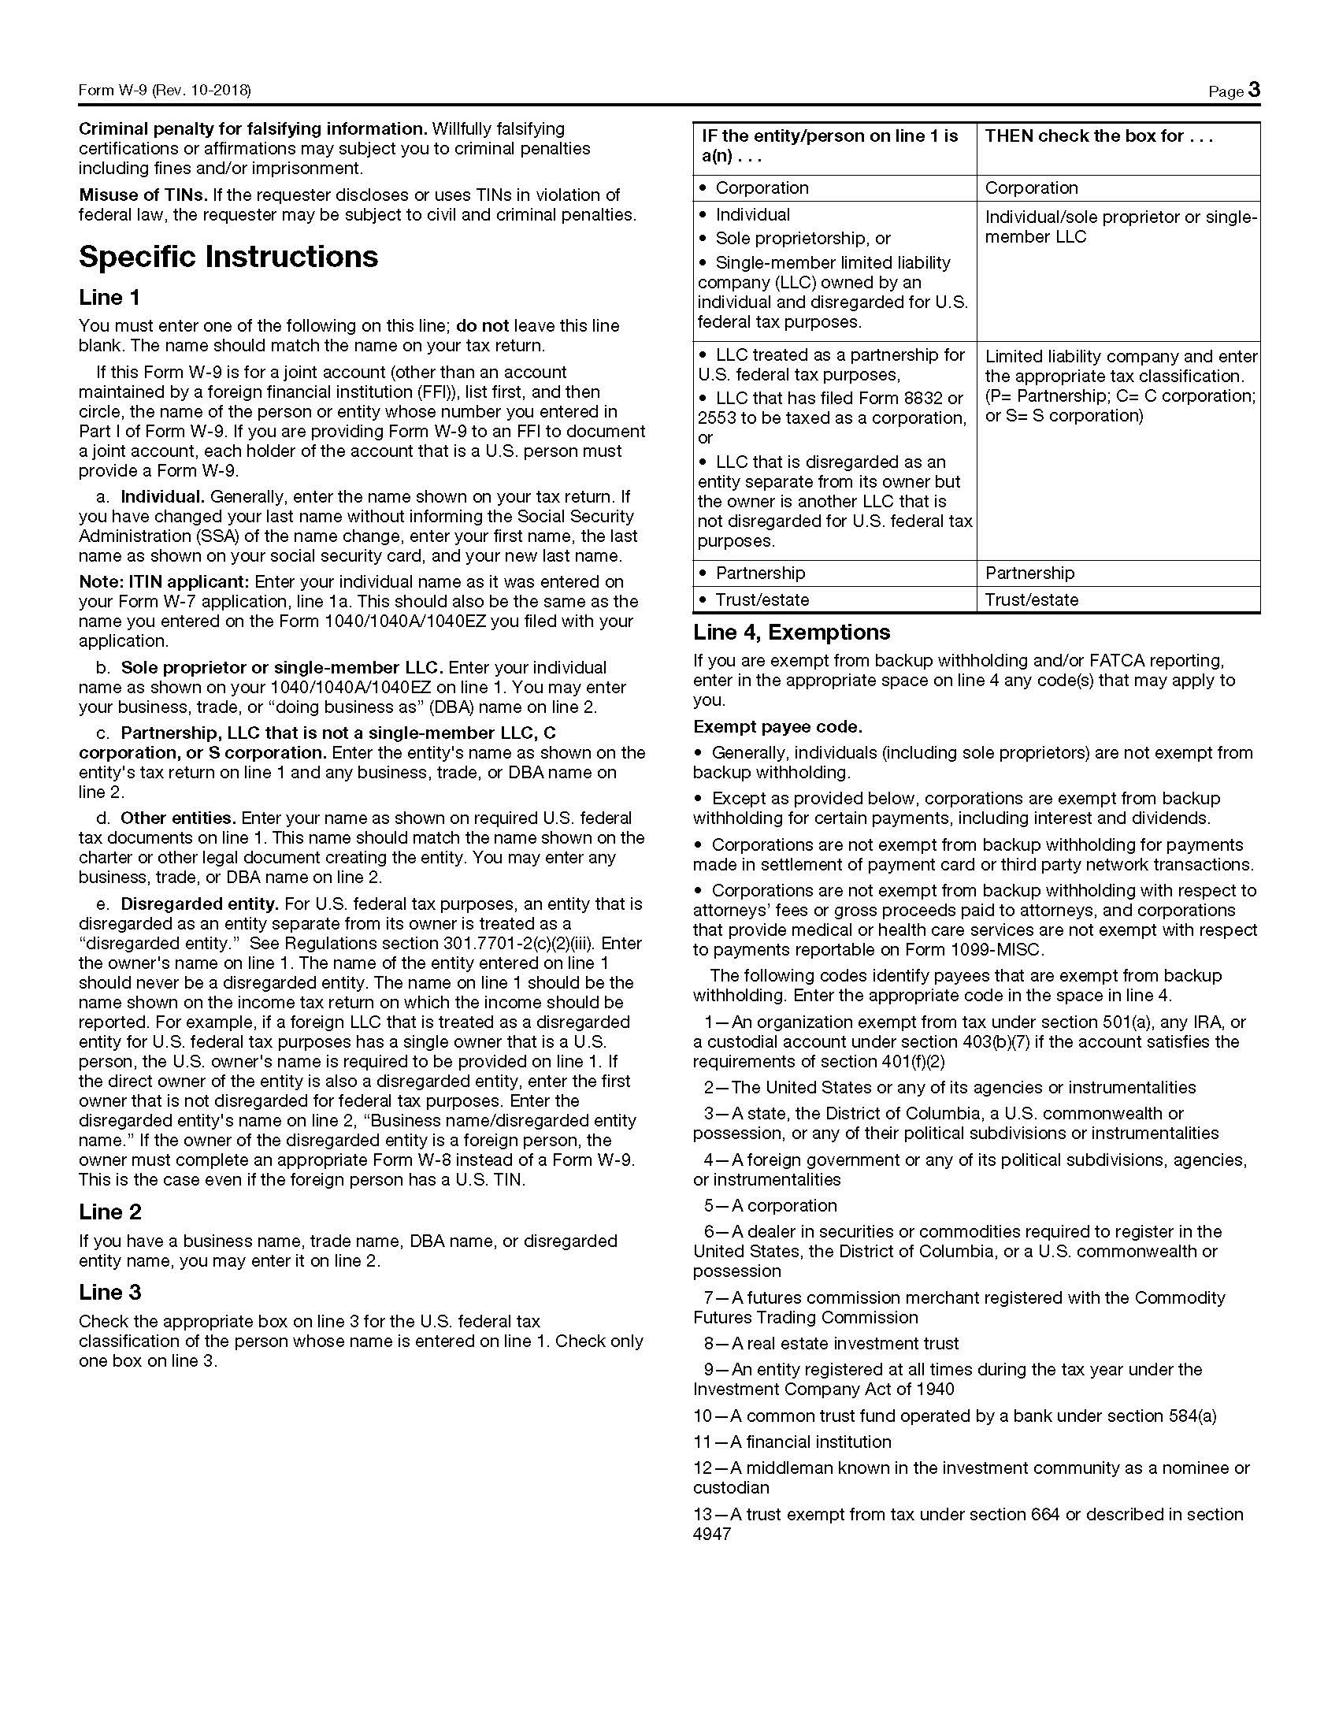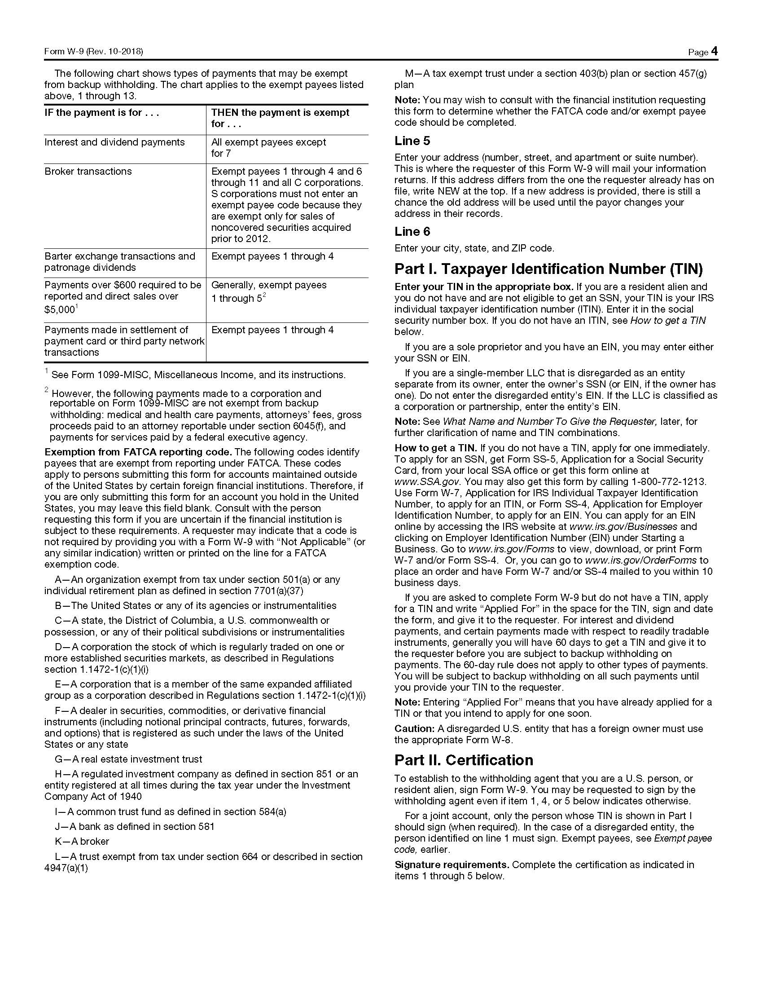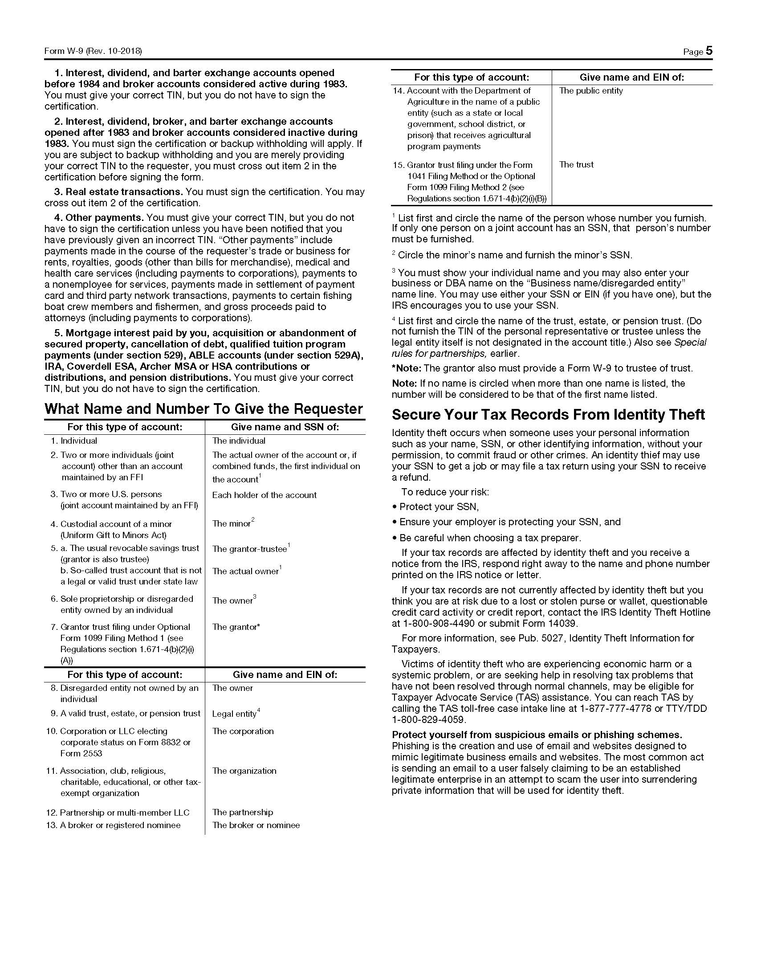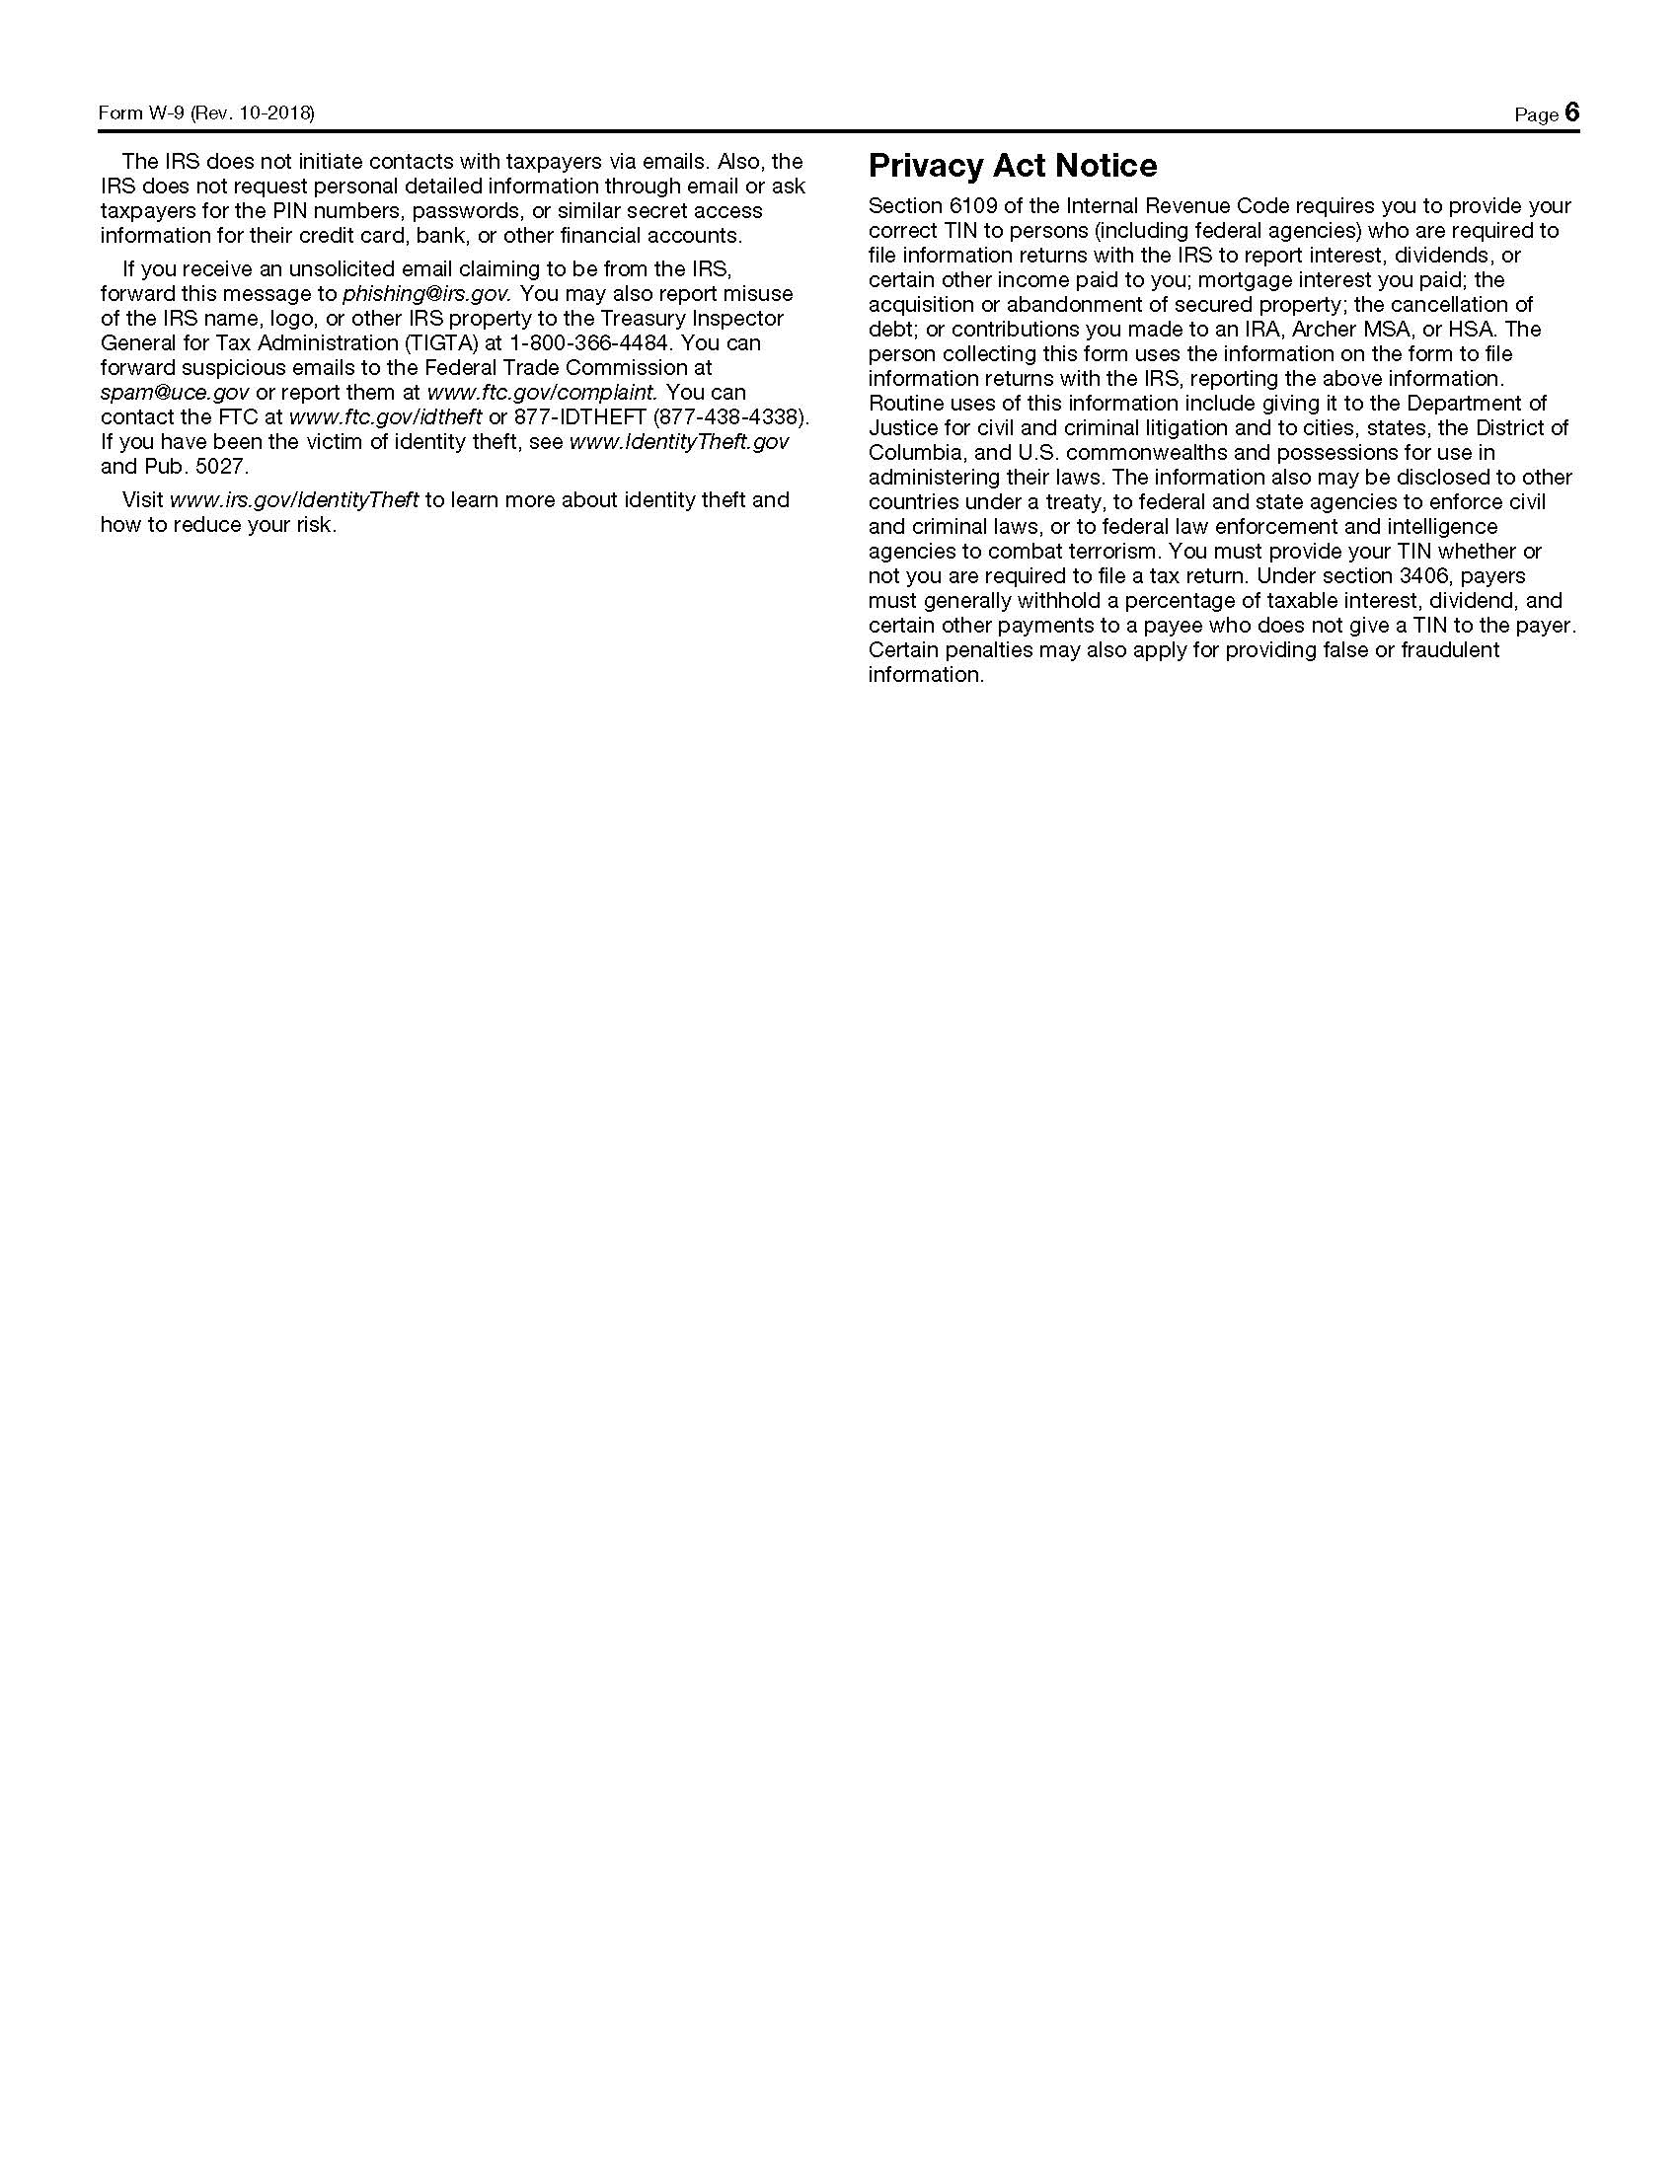
L – REFERENCES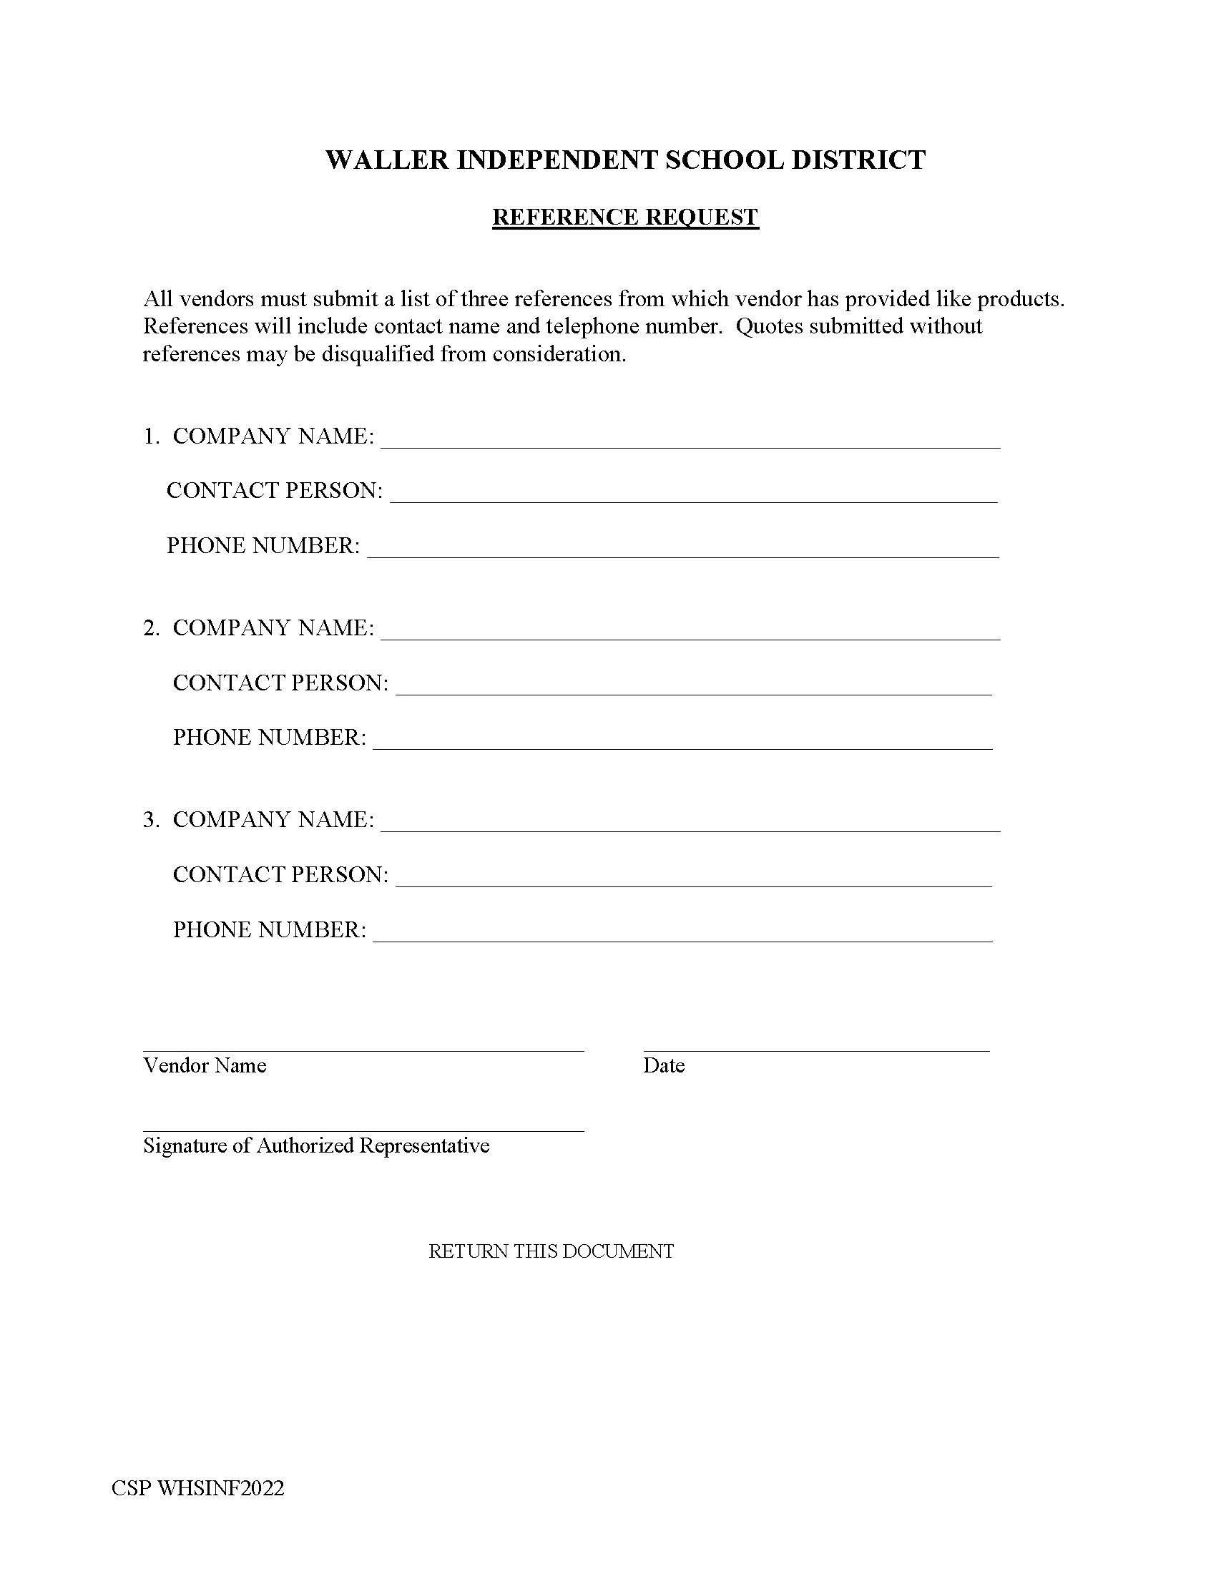

M – COOPERATIVE CONTRACTS

COOOPERATIVE NAME | CONTRACT  NUMBER | CONTRACT EXPIRATION  DATE
HCDE (Choice Partners)
TASB (BuyBoard)
Houston Galveston Council of Governments Cooperative (HGAC)
ESC Region 8 Cooperative (TIPS)
ESC Region 5 Cooperative (SETX)
Omnia Partners
State of Texas (TXMAS)
Department of Information Resources (DIR)
GSA (General Services Administration)
Purchasing Solutions Alliance (PSA)
New Caney ISD (SPA)
Sourcewell
None
 | DISTRICT NAME | CONTRACT NUMBER
Central Texas Purchasing Alliance (CTPA)
Please list any cooperative contracts currently held by Vendor.

N – BID ACCEPTANCE FORM
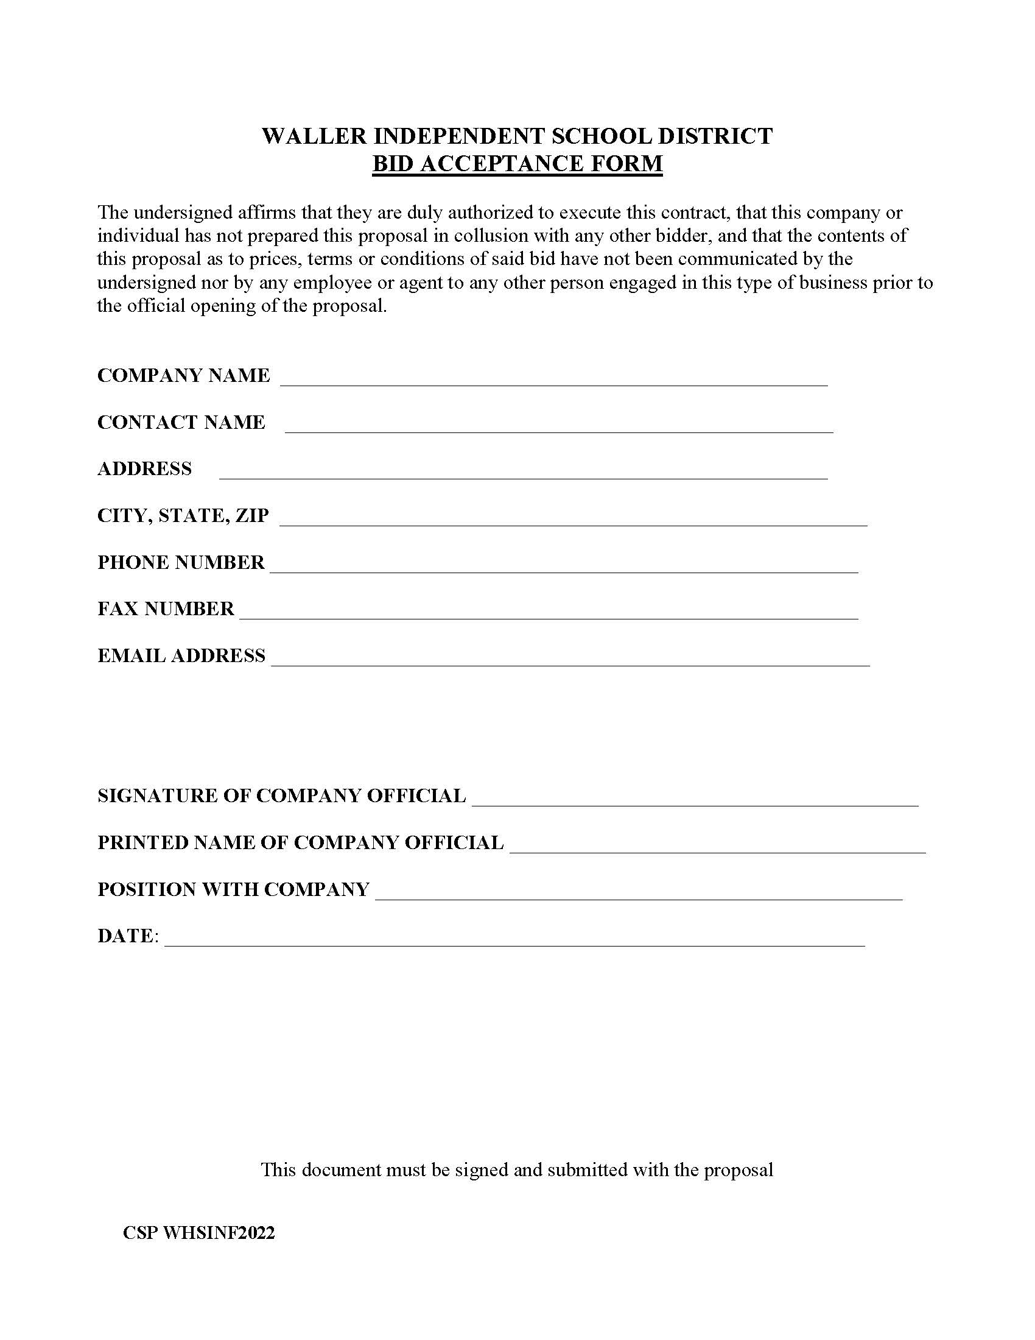

“Contracting information” is defined by Tex. Gov’t Code § 552.003(7) as “the following information maintained by a governmental body or sent between a governmental body and a vendor, contractor, potential vendor, or potential contractor: (A) information in a voucher or contract relating to the receipt or expenditure of public funds by a governmental body; (B) solicitation or bid documents relating to a contract with a governmental body; (C) communications sent between a governmental body and a vendor, contractor, potential vendor, or potential contractor during the solicitation, evaluation, or negotiation of a contract; (D) documents, including bid tabulations, showing the criteria by which a governmental body evaluates each vendor, contractor, potential vendor, or potential contractor responding to a solicitation and, if applicable, an explanation of why the vendor or contractor was selected; and (E) communications and other information sent between a governmental body and a vendor or contractor related to the performance of a final contract with the governmental body or work performed on behalf of the governmental body.”

