Empire Public School Campus 2022-2023
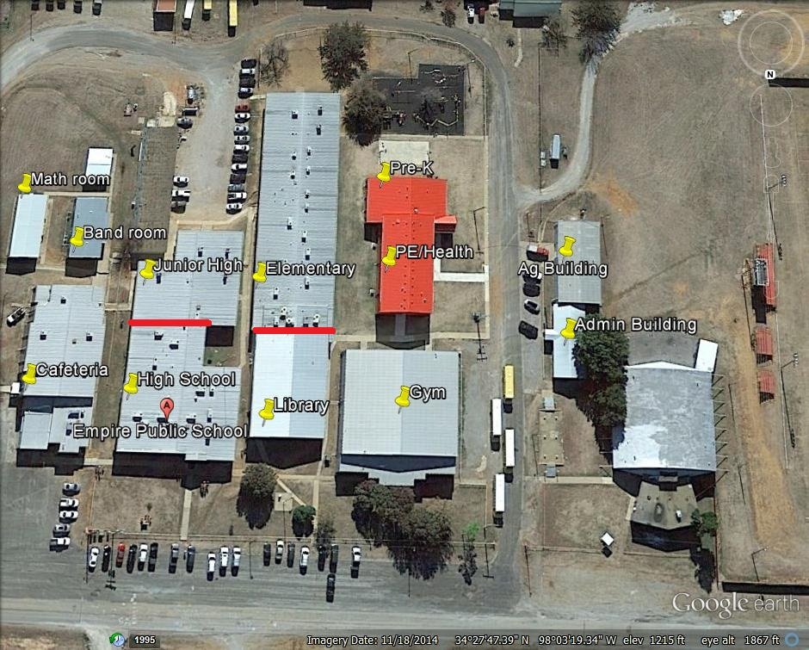
Switch Locations:
Ag Building, Server Room in Library, Computer lab 1 and Computer lab 2 in the elementary, Computer lab in the high school, Resource room in the high school, Storage room in the high school, Band room.
Access Point current locations:
1-Math room; 1-Pre-K; 1-Library; 1-Ag Building; 7-Elementary hallway; 4-High school hallway; 4-Junior High hallway
New Access Point locations and cabling for each
1 in every classroom: (2 PK, 1 PE/Health, 19 classrooms in elementary, 1 AG, 2 Math rooms, 1 band room, 9 classrooms in high school, 8 classrooms in junior high, 2 library,)
. All current access points are being replaced, however, in different locations. They are currently in hallways, we are placing one in each classroom. Locations of switches are also on this map.

