The St. Clair High School – to - Elementary school fiber installed last year replaced a leased dark fiber. The equipment at each end that lights this fiber is an HP 5412 switch (9yrs old). It is a layer 3 switch that can accommodate both fiber and twisted-pair modules. On the High School side we are using 16 Fiber ports and 78 twisted- pair ports. On the Elementary side we are using 4 fiber ports and 112 twisted-pair ports.
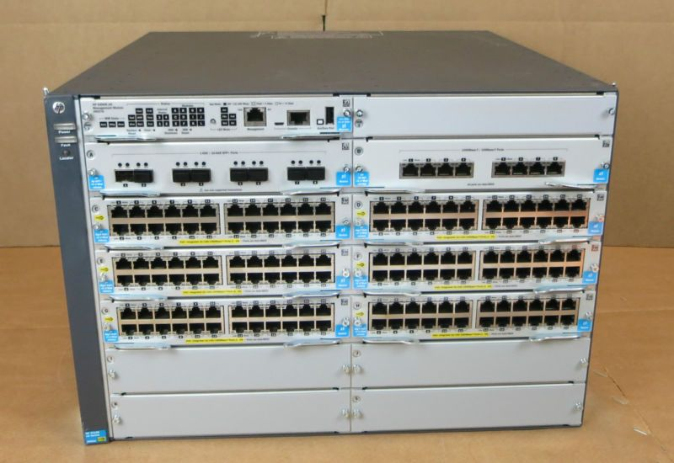

For the purposes of Erate, we can purchase this switch with just one fiber module installed. Then the district could purchase the other fiber and twisted-pair modules that we would require independently.
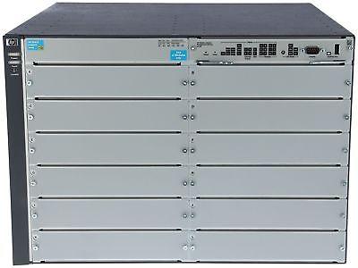
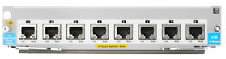

The Empty Chassis is an Aruba 5412R zl2 Model # j9822A , or functional equivalent. x 2
The Fiber Module is Aruba 8-port 1G/10GbE SFP+ Module Model # J9993A, or functional equivalent. x 2

The other option would be to add another piece of equipment (switch) between the existing 5412 switch and the fiber run. The Aruba 2930F switch Model # JL558A, or functional equivalent. x 2
This is not ideal, and would add two more hops in the connection between the High School and the Elementary School.

